News Clips for the Week
(Newclb55)

Volcanoes

Activity for the week of 6 September-12 September 2017

The Weekly Volcanic Activity Report is a cooperative project between the Smithsonian's Global Volcanism Program and the US Geological Survey's Volcano Hazards Program. Updated by 2300 UTC every Wednesday, notices of volcanic activity posted on these pages are preliminary and subject to change as events are studied in more detail. This is not a comprehensive list of all of Earth's volcanoes erupting during the week, but rather a summary of activity at volcanoes that meet criteria discussed in detail in the "Criteria and Disclaimers" section. Carefully reviewed, detailed reports on various volcanoes are published monthly in the Bulletin of the Global Volcanism Network.
Name | Location | Activity
Aoba | Vanuatu | New
Fernandina | Ecuador | New
Nevados de Chillan | Chile | New
Villarrica | Chile | New
Aira | Kyushu (Japan) | Ongoing
Bagana | Bougainville (Papua New Guinea) | Ongoing
Bezymianny | Central Kamchatka (Russia) | Ongoing
Bogoslof | Fox Islands (USA) | Ongoing
Cleveland | Chuginadak Island (USA) | Ongoing
Dukono | Halmahera (Indonesia) | Ongoing
Ebeko | Paramushir Island (Russia) | Ongoing
Kilauea | Hawaiian Islands (USA) | Ongoing
Klyuchevskoy | Central Kamchatka (Russia) | Ongoing
Langila | New Britain (Papua New Guinea) | Ongoing
Poas | Costa Rica | Ongoing
Sabancaya | Peru | Ongoing
Sangay | Ecuador | Ongoing
Sheveluch | Central Kamchatka (Russia) | Ongoing
Sinabung | Indonesia | Ongoing
Suwanosejima | Ryukyu Islands (Japan) | Ongoing
Turrialba | Costa Rica | Ongoing

New Activity/Unrest
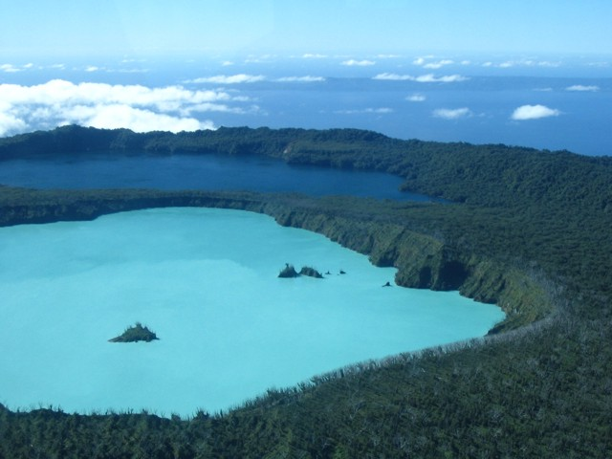 Aoba | Vanuatu | 15.4°S, 167.83°E | Elevation 1496 m
On 30 August the Vanuatu Geohazards Observatory (VGO) stated that conditions at Aoba had been changing, increasing the potential for eruptive activity. On 6 September a VGO report noted that activity continued to increase; the Alert Level was raised to 3 (on a scale of 0-4) signifying that the volcano is in a minor eruption phase. VGO reminded residents and tourists not to approach the volcano within a 3-km radius, and to stay out of areas subject to trade-wind exposure.
Source: Vanuatu Geohazards Observatory

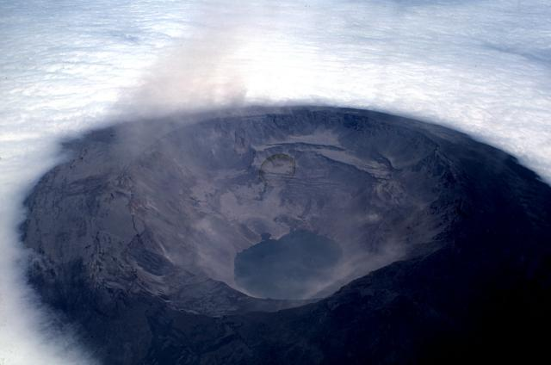 Fernandina | Ecuador | 0.37°S, 91.55°W | Elevation 1476 m
IG reported that activity at Fernandina began on 4 September with the detection of hybrid earthquakes followed by long-period events, and finally the onset of tremor at 1225 which heralded the beginning of the eruption. Lava emerged from a circumferential fissure near the SSW rim of the caldera and flowed down the S and SW flanks (with no evidence of the flows reaching the sea). A gas plume with low ash content rose 4 km above the crater rim and drifted W. Flows continued to be active on 5 September but by the evening the intensity had weakened. An eruptive plume rose about 2.5 km. Activity decreased significantly by 6 September.
Source: Instituto Geofísico-Escuela Politécnica Nacional (IG)

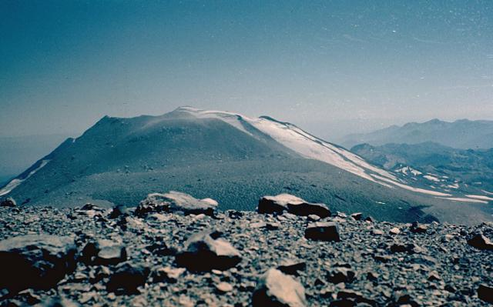 Nevados de Chillan | Chile | 36.863°S, 71.377°W | Elevation 3212 m
According to Oficina Nacional de Emergencia-Ministerio del Interior (ONEMI), Servicio Nacional de Geología and Minería (SERNAGEOMIN) Observatorio Volcanológico de Los Andes del Sur (OVDAS) reported that during 16-31 August phreato-magmatic explosions at Nevados de Chillán's Volcán Arrau dome complex had decreased. The Alert Level remained at Yellow, the middle level on a three-color scale, and the public was reminded not to approach the craters within a 3-km radius.
Source: Oficina Nacional de Emergencia-Ministerio del Interior (ONEMI)

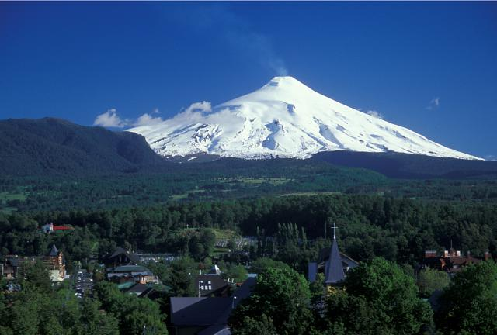 Villarrica | Chile | 39.42°S, 71.93°W | Elevation 2847 m
In a summary of August activity at Villarrica, Proyecto Observación Villarrica Internet (POVI) reported that the crater was only partially visible on nine days. On 2 September a small incandescent vent at the bottom of the crater was visible. An explosion at 0924 on 30 August ejected gas and ash that drifted E due to strong winds; observers noted ash and lapilli deposits on the snow during a field visit later that day.
Source: Proyecto Observación Villarrica Internet (POVI)

Ongoing Activity
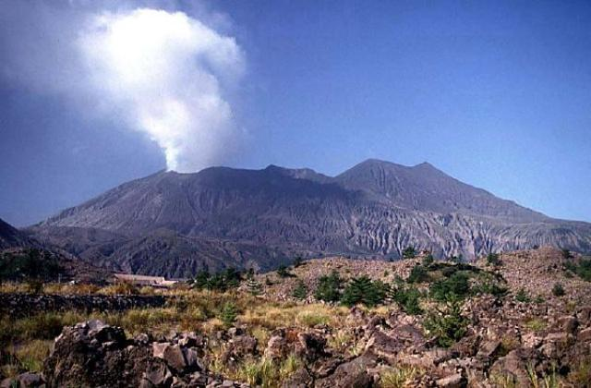 Aira | Kyushu (Japan) | 31.593°N, 130.657°E | Elevation 1117 m
JMA reported that 30 explosive events at Showa Crater (at Aira Caldera’s Sakurajima volcano) during 4-11 September ejected material as far as 800 m. Ash plumes rose as high as 2.2 km above the crater rim. Crater incandescence was observed most nights. The Alert Level remained at 3 (on a 5-level scale).
Source: Japan Meteorological Agency (JMA)

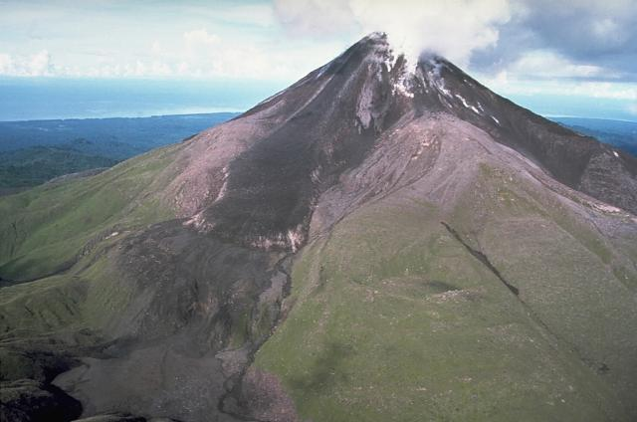 Bagana | Bougainville (Papua New Guinea) | 6.137°S, 155.196°E | Elevation 1855 m
Based on analyses of satellite imagery and model data, the Darwin VAAC reported that during 11-12 September an ash plume from Bagana rose to an altitude of 2.1 km (7,000 ft) a.s.l. and drifted NW.
Source: Darwin Volcanic Ash Advisory Centre (VAAC)

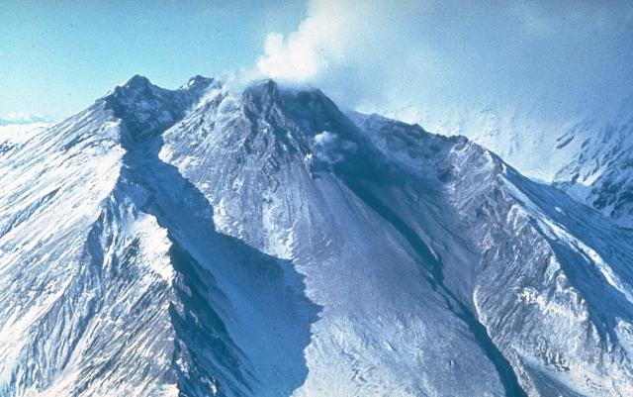 Bezymianny | Central Kamchatka (Russia) | 55.972°N, 160.595°E | Elevation 2882 m
KVERT reported that during 1-8 September a thermal anomaly over Bezymianny was identified daily in satellite images. A lava flow continued to flow down the W flank of the dome; incandescence from the dome was visible at night. The Aviation Color Code remained at Orange (the second highest level on a four-color scale).
Source: Kamchatkan Volcanic Eruption Response Team (KVERT)

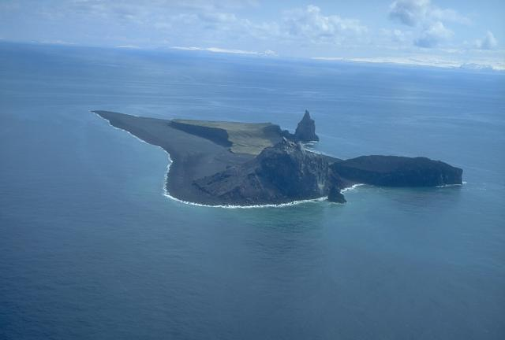 Bogoslof | Fox Islands (USA) | 53.93°N, 168.03°W | Elevation 150 m
AVO reported that during 6-12 September nothing significant was observed in mostly cloudy satellite images of Bogoslof, and no activity was detected in seismic or infrasound data. The 8 September report noted that the crater lake had been bisected by a narrow isthmus of land. Elevated surface temperatures were identified in one satellite image during 10-11 September. The Aviation Color Code remained at Orange and the Volcano Alert Level remained at Watch.
Source: US Geological Survey Alaska Volcano Observatory (AVO)

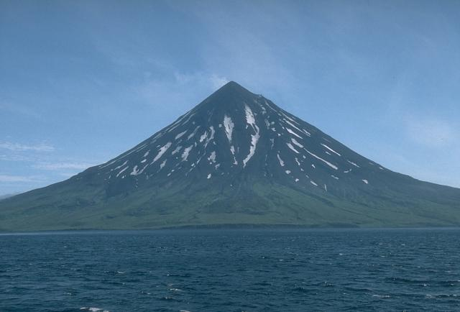 Cleveland | Chuginadak Island (USA) | 52.825°N, 169.944°W | Elevation 1730 m
AVO reported that during 6-12 September nothing significant was observed in often cloudy satellite images and web camera views of Cleveland; minor steaming was noted during 10-11 September. In addition, nothing noteworthy was detected in seismic or infrasound data. The Aviation Color Code remained at Orange and the Volcano Alert Level remained at Watch.
Source: US Geological Survey Alaska Volcano Observatory (AVO)

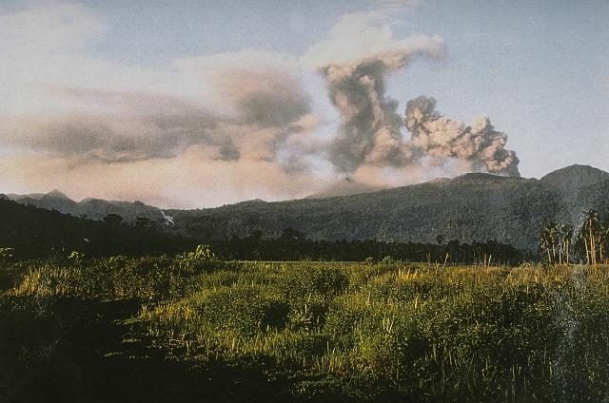 Dukono | Halmahera (Indonesia) | 1.693°N, 127.894°E | Elevation 1229 m
Based on analyses of satellite imagery, wind model data, and notices from PVMBG, the Darwin VAAC reported that during 6-10 and 12 September ash plumes from Dukono rose to an altitude of 2.1 km (7,000 ft) a.s.l. and drifted SW, W, and NW.
Source: Darwin Volcanic Ash Advisory Centre (VAAC)

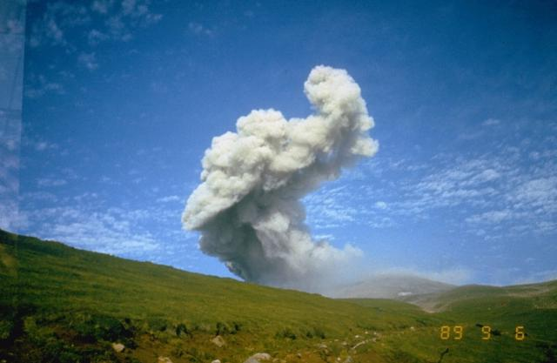 Ebeko | Paramushir Island (Russia) | 50.686°N, 156.014°E | Elevation 1103 m
Based on observations by volcanologists in Severo-Kurilsk (Paramushir Island), about 7 km E of Ebeko, explosions on 2 September generated ash plumes that rose 4 km (13,100 ft) a.s.l. Explosions during 3 and 6-7 September produced ash plumes that rose 2.1 km (6,900 ft) a.s.l. Minor amounts of ash fell in Severo-Kurilsk during 2-3 and 6-7 September. The Aviation Color Code remained at Orange (the second highest level on a four-color scale).
Source: Kamchatkan Volcanic Eruption Response Team (KVERT)

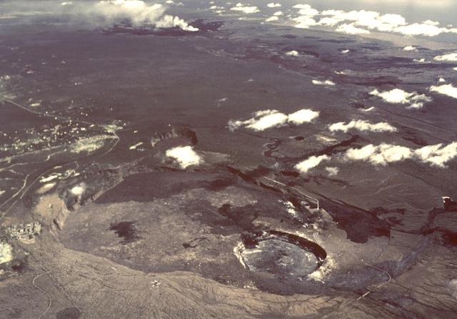 Kilauea | Hawaiian Islands (USA) | 19.421°N, 155.287°W | Elevation 1222 m
During 6-12 September HVO reported that the lava lake continued to rise, fall, and spatter in Kilauea’s Overlook crater, though a deflationary trend the second half of the week caused the lake level to mostly drop. Several rockfalls and collapses of the inner crater wall veneer were noted during 7-10 September; frequent rockfalls were not uncommon during periods of lake level lowering. Webcams recorded incandescence from long-active sources within Pu'u 'O'o Crater and from a small lava pond in a pit on the W side of the crater. The 61G lava flow, originating from a vent on Pu'u 'O'o Crater's E flank, continued to enter the ocean at Kamokuna. Surface lava flows were active above and on the pali, and on the coastal plain. HVO noted that cracks running parallel to the coastline underscored the potential for bench collapse into the sea.
Source: US Geological Survey Hawaiian Volcano Observatory (HVO)

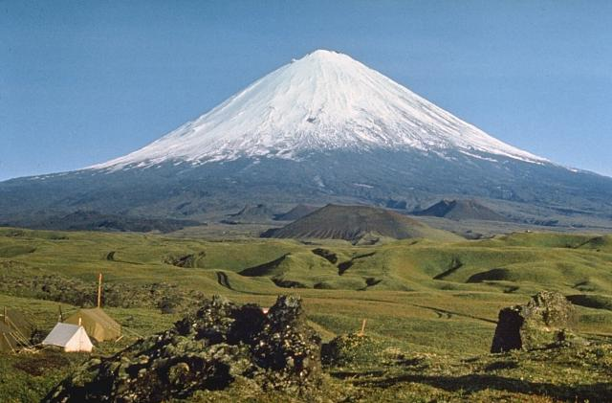 Klyuchevskoy | Central Kamchatka (Russia) | 56.056°N, 160.642°E | Elevation 4754 m
KVERT reported that on 7 September explosions at Klyuchevskoy recorded by a webcam generated ash plumes that rose as high as 6 km (19,700 ft) a.s.l. and drifted about 50 km NE. The Aviation Color Code remained at Orange (the second highest level on a four-color scale).
Source: Kamchatkan Volcanic Eruption Response Team (KVERT)

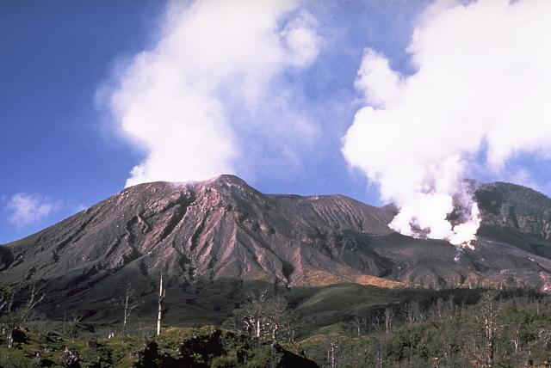 Langila | New Britain (Papua New Guinea) | 5.525°S, 148.42°E | Elevation 1330 m
Based on analyses of satellite imagery and model data, the Darwin VAAC reported that during 7-8 and 10-12 September ash plumes from Langila rose 1.8-2.4 km (6,000-8,000 ft) a.s.l. and drifted NNW, NW, and SW.
Source: Darwin Volcanic Ash Advisory Centre (VAAC)

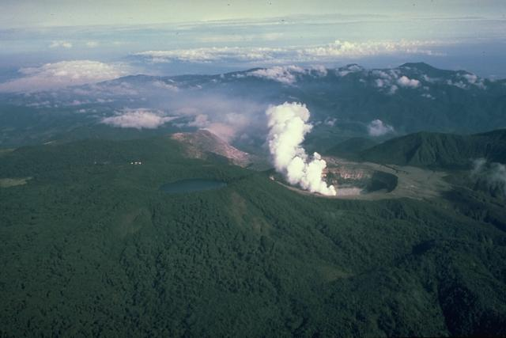 Poas | Costa Rica | 10.2°N, 84.233°W | Elevation 2708 m
OVSICORI-UNA reported that an event at Poás at 0820 on 13 September generated plume that rose 300 m above the crater rim.
Source: Observatorio Vulcanologico y Sismologico de Costa Rica-Universidad Nacional (OVSICORI-UNA)

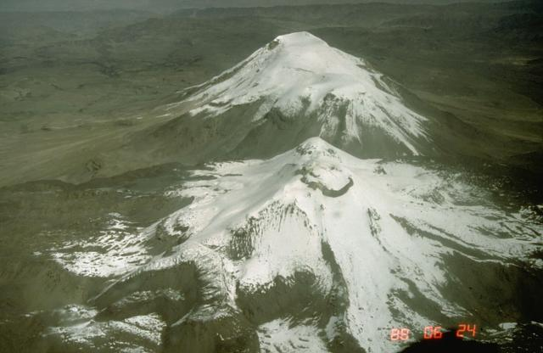 Sabancaya | Peru | 15.787°S, 71.857°W | Elevation 5960 m
Observatorio Vulcanológico del Sur del IGP (OVS-IGP) and Observatorio Vulcanológico del INGEMMET (OVI) reported that explosive activity at Sabancaya was slightly lower compared to the previous week; there was an average of 38 explosions recorded per day during 4-10 September. The earthquakes were dominated by long-period signals, with fewer numbers of hybrid events and emission signals. Gas-and-ash plumes rose 3.5 km above the crater rim and drifted no more than 40 km SE. The MIROVA system detected five thermal anomalies. The report warned the public not to approach the crater within a 12-km radius.
Sources: Instituto Geológico Minero y Metalúrgico (INGEMMET), Instituto Geofísico del Perú (IGP)

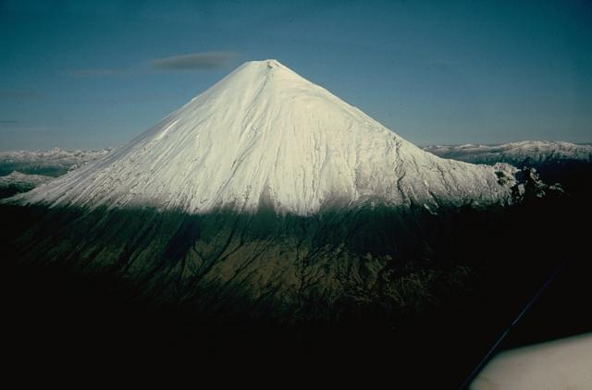 Sangay | Ecuador | 2.005°S, 78.341°W | Elevation 5286 m
Based on information from the Guayaquil MWO, the Washington VAAC reported that on 6 September an emission from Sangay rose 7.3 km (24,000 ft) a.s.l.
Source: Washington Volcanic Ash Advisory Center (VAAC)

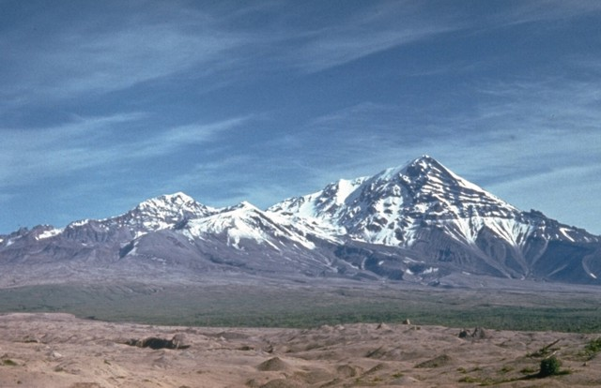 Sheveluch | Central Kamchatka (Russia) | 56.653°N, 161.36°E | Elevation 3283 m
KVERT reported that a thermal anomaly over Sheveluch was identified daily in satellite images during 2-3 and 6-7 September. Two explosive events on 7 September generated ash plumes that rose 8-10 km (26,200-32,800 ft) a.s.l. and drifted NE, SE, and S. The Aviation Color Code remained at Orange.
Source: Kamchatkan Volcanic Eruption Response Team (KVERT)

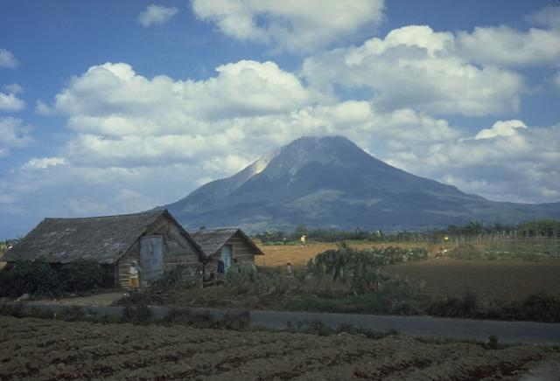 Sinabung | Indonesia | 3.17°N, 98.392°E | Elevation 2460 m
Based on observations by PVMBG, webcam and satellite images, and model data, the Darwin VAAC reported that during 6-8 and 12 September ash plumes from Sinabung rose 3-5.5 km (10,000-18,000 ft) a.s.l. and drifted W, NW, and E.
Source: Darwin Volcanic Ash Advisory Centre (VAAC)

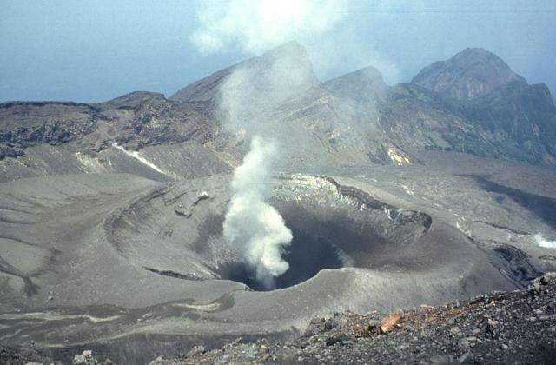 Suwanosejima | Ryukyu Islands (Japan) | 29.638°N, 129.714°E | Elevation 796 m
Based on JMA notices and satellite-image analyses, the Tokyo VAAC reported explosions on 6 September generated plums that rose 1.5-1.8 km (5,000-6,000 ft) a.s.l. and drifted E.
Source: Tokyo Volcanic Ash Advisory Center (VAAC)

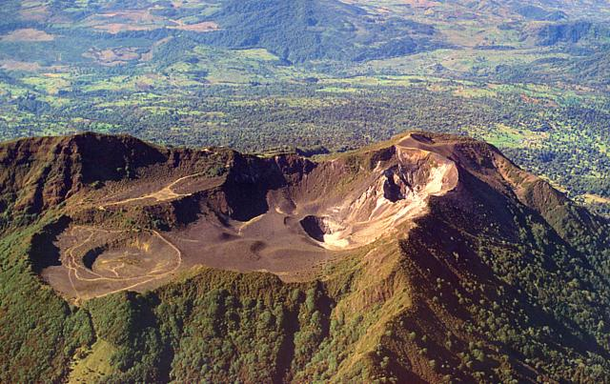 Turrialba | Costa Rica | 10.025°N, 83.767°W | Elevation 3340 m
OVSICORI-UNA reported that an event at Turrialba at 0730 on 11 September generated a plume that rose 500 m above the crater rim and drifted N. Another event at 0820 on 13 September passively produced an ash plume that rose 100 m and drifted NW.
Source: Observatorio Vulcanologico y Sismologico de Costa Rica-Universidad Nacional (OVSICORI-UNA)

http://volcano.si.edu/reports_weekly.cfm

Kilauea volcano expels lava in spectacular eruption in Hawaii
Asia One
Tue, 12 Sep 2017 12:33 UTC
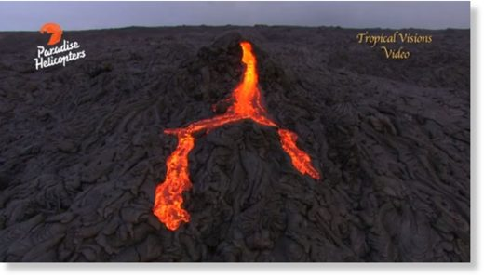
© Paradise Helicopters, Tropical Visions Video
KILAUEA VOLCANO

Liquid lava flowed at the Kilauea Volcano on Hawaii's Big Island on Thursday (September 7).
The Kilauea volcano has erupted from its Pu'u O'o vent since 1983.
Late this week, Kilauea, the world's most active volcano sent streams of lava rolling down a 30-foot cone.
The outbreak came from a break at the top of a huge tumulus just above the cliffs about four miles below the active Pu'u 'O'o vent.
The eruption, dubbed 61G by the USGS began in early 2016 and has been entering the ocean nearby since summer of that year.

https://www.sott.net/article/361753-Kilauea-volcano-expels-lava-in-spectacular-eruption-in-Hawaii

Earthquakes

Weekly Summary From USGS

Magnitudes and Quantities

2017 Week |  | # 8+ | # 7 | # 6 | # 5 | # 2.5 - 4 | Total This Week | Week Total this Time 2016 | Week Total this Time 2015 | Week Total This Time 2014 | Week Total This Time 2013
1 |  | 0 | 0 | 2 | 43 | 206 | 251 | 424 | 266 | 206 | 321
2 |  | 0 | 1 | 2 | 35 | 144 | 182 | 294 | 243 | 554 | 237
3 |  | 0 | 0 | 1 | 23 | 184 | 208 | 262 | 199 | 313 | 249
4 |  | 0 | 1 | 0 | 25 | 226 | 252 | 368 | 374 | 291 | 226
5 |  | 0 | 0 | 0 | 20 | 182 | 202 | 262 | 240 | 245 | 380
6 |  | 0 | 0 | 2 | 32 | 166 | 200 | 259 | 245 | 243 | 236
7 |  | 0 | 0 | 1 | 24 | 185 | 210 | 298 | 264 | 230 | 139
8 |  | 0 | 0 | 2 | 27 | 228 | 257 | 281 | 244 | 230 | 211
9 |  | 0 | 0 | 0 | 28 | 210 | 238 | 298 | 237 | 242 | 184
10 |  | 0 | 0 | 1 | 24 | 209 | 234 | 215 | 229 | 373 | 217
11 |  | 0 | 0 | 1 | 30 | 260 | 291 | 272 | 273 | 311 | 162
12 |  | 0 | 0 | 1 | 17 | 198 | 216 | 230 | 270 | 297 | 229
13 |  | 0 | 0 | 2 | 34 | 243 | 279 | 237 | 269 | 391 | 220
14 |  | 0 | 0 | 2 | 31 | 279 | 312 | 288 | 260 | 321 | 245
15 |  | 0 | 0 | 1 | 29 | 255 | 285 | 308 | 219 | 407 | 311
16 |  | 0 | 0 | 1 | 22 | 261 | 284 | 285 | 277 | 305 | 202
17 |  | 0 | 0 | 2 | 40 | 237 | 279 | 256 | 254 | 257 | 202
18 |  | 0 | 0 | 2 | 28 | 398 | 428 | 241 | 338 | 308 | 252
19 |  | 0 | 0 | 5 | 43 | 257 | 305 | 263 | 303 | 253 | 231
20 |  | 0 | 0 | 1 | 23 | 222 | 246 | 261 | 286 | 230 | 395
21 |  | 0 | 0 | 0 | 20 | 245 | 265 | 225 | 243 | 239 | 223
22 |  | 0 | 0 | 3 | 25 | 192 | 220 | 246 | 253 | 262 | 246
23 |  | 0 | 0 | 0 | 19 | 192 | 211 | 248 | 252 | 230 | 194
24 |  | 0 | 0 | 4 | 23 | 226 | 253 | 209 | 217 | 270 | 236
25 |  | 0 | 0 | 1 | 22 | 213 | 236 | 258 | 228 | 372 | 192
26 |  | 0 | 0 | 4 | 15 | 202 | 221 | 271 | 212 | 253 | 204
27 |  | 0 | 0 | 1 | 19 | 241 | 261 | 226 | 226 | 244 | 190
28 |  | 0 | 0 | 2 | 21 | 250 | 273 | 239 | 358 | 274 | 258
29 |  | 0 | 1 | 3 | 26 | 234 | 264 | 229 | 310 | 249 | 217
30 |  | 0 | 0 | 0 | 22 | 211 | 233 | 236 | 566 | 204 | 217
31 |  | 0 | 0 | 0 | 30 | 214 | 244 | 215 | 327 | 223 | 210
32 |  | 0 | 0 | 3 | 33 | 220 | 256 | 245 | 225 | 240 | 269
33 |  | 0 | 0 | 3 | 23 | 195 | 221 | 245 | 247 | 275 | 194
34 |  | 0 | 0 | 0 | 10 | 208 | 218 | 250 | 284 | 175 | 293
35 |  | 0 | 0 | 2 | 23 | 210 | 235 | 322 | 352 | 314 | 254
36 |  | 1 | 0 | 3 | 33 | 456 | 493 | 267 | 303 | 254 | 231
37 |  |  |  |  |  |  | 0 | 227 | 411 | 269 | 247
38 |  |  |  |  |  |  | 0 | 312 | 346 | 43 | 246
39 |  |  |  |  |  |  | 0 | 287 | 346 | 277 | 218
40 |  |  |  |  |  |  | 0 | 189 | 215 | 254 | 231
41 |  |  |  |  |  |  | 0 | 183 | 273 | 313 | 272
42 |  |  |  |  |  |  | 0 | 251 | 260 | 296 | 235
43 |  |  |  |  |  |  | 0 | 298 | 276 | 265 | 197
44 |  |  |  |  |  |  | 0 | 216 | 274 | 355 | 261
45 |  |  |  |  |  |  | 0 | 233 | 286 | 322 | 250
46 |  |  |  |  |  |  | 0 | 357 | 308 | 354 | 353
47 |  |  |  |  |  |  | 0 | 269 | 271 | 289 | 211
48 |  |  |  |  |  |  | 0 | 219 | 242 | 256 | 240
49 |  |  |  |  |  |  | 0 | 300 | 307 | 261 | 192
50 |  |  |  |  |  |  | 0 | 292 | 225 | 277 | 218
51 |  |  |  |  |  |  | 0 | 266 | 237 | 258 | 231
52 |  |  |  |  |  |  | 0 | 259 | 252 | 275 | 222
 |  | 1 | 3 | 58 | 942 | 8259 | 9263 | 13691 | 14955 | 15101 | 12301

8.5 magnitude earthquake hits Oaxaca, Mexico, cutting power and sparking mysterious lights
RT
Fri, 08 Sep 2017 18:04 UTC
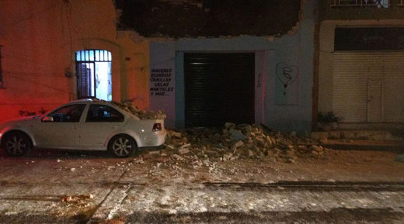
© Global Look Press
A building damaged during an earthquake in Tuxtla Gutierrez, Chiapas state, Mexico

The death toll from an 8.2-magnitude earthquake that hit Mexico has reached at least 32, according to tallies from local authorities.
Twenty-three of the confirmed fatalities were in the state of Oaxaca, according to its governor. Seventeen of those deaths occurred in the town of Juchitan.
Seven people were killed in the state of Chiapas, where a state of emergency has been declared, according to a spokesman for emergency services cited by Reuters.
Two children were killed in neighboring Tabasco state, according to its governor. One was crushed by a collapsing wall, while the other - an infant on a respirator - died after the quake triggered a power outage in the hospital.
The epicenter of the quake was at a depth of 33 km (21 miles), 123 km (76 miles) southwest of the town of Pijijiapan, not far from the Guatemalan border.
"It was a major earthquake in scale and magnitude, the strongest in the past 100 years," President Peña Nieto said in an address from the National Disaster Prevention Centre's headquarters, where he was supervising the emergency response.
The US Geological Survey reported the quake's magnitude at 8.1.
Peña Nieto said the quake was felt by 50 million of the country's 120 million residents, and was also felt in much of Guatemala, which borders Chiapas.
Waves of more than 3.3 feet (1 meter) were measured off Salina Cruz, Mexico, following the quake, according to the Pacific Tsunami Warning Center. Smaller waves were observed in several other locations.
Peña Nieto has warned that more aftershocks are likely, and has urged people to check their homes and offices for structural damage and gas leaks.
Officials have ordered schools in 11 states to remain closed on Friday, including in Mexico City, so officials can inspect for structural damage.
Mexico sits atop five tectonic plates, with their movement making it one of the most seismically-active countries in the world.
The most destructive earthquake to hit the country to date was in 1985, when an 8.1 magnitude quake killed more than 10,000 people in the capital, Mexico City.
Comment: Hospital ventilators failed as the earthquake struck:
The quake caused widespread power outages and as a 0.7-metre wave hit the country, the Pacific Tsunami Warning Centre confirmed more hazardous tsunamis were possible within three hours.
The death toll includes two children in Tabasco state.
Tabasco Govenor Arturo Nunez said one of the children died when a wall collapsed, and the other was a baby who died in a children's hospital that lost electricity, cutting off the supply to the infant's ventilator.
Earthquake lights, a commonly reported phenomenon, were seen:
One person took a video of the earthquake light phenomenon which often happens after an earthquake strikes.
Little is known about why they occur and some believe it may be as a result of power supplies being hit while others claim that they have been reported for thousands of years.
Seismologist Stephen Hicks said: 'Earthquake lights have never been proven. Simpler explanation is small explosions in electric generators and power systems.
The lights are similar to auroras and can sometimes continue for several minutes after or before the quake.
For example in 1975, the mystery lights appeared during and immediately after the main shock in the Kalapana earthquake in Hawaii.
They come in many colours and forms and people have reported seeing them for hundreds of years but only recently have scientists come a little closer to establishing why they appear.
More on the light phenonmenon:
Another explanation claims that the tectonic movement of rocks including quartz, generates a piezoelectric field which produces flashes of light.
A 2014 study said the stress of the tectonic plates can break apart pairs of negatively-charged oxygen atoms, pushing them towards the Earth's surface and forming a light-emitting plasma when it combines with air.

https://www.sott.net/article/361477-8-5-magnitude-earthquake-hits-Oaxaca-Mexico-cutting-power-and-sparking-mysterious-lights

5.4 magnitude earthquake strikes near San Francisco del Mar in Mexico
Earthquakes Today
Fri, 08 Sep 2017 18:54 UTC
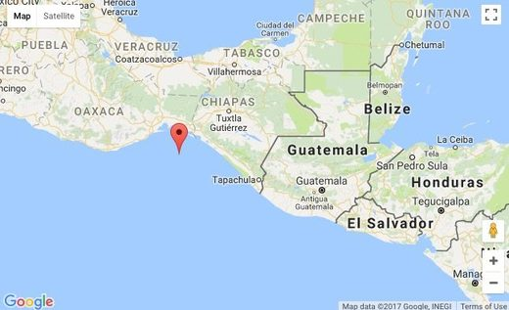
© Google

A moderate earthquake magnitude 5.4 (ml/mb) has occurred on Thursday, 75 kilometers (47 miles) from San Francisco del Mar in Mexico. A tsunami warning has not been issued (Does not indicate if a tsunami actually did or will exist).
Event ids that are associated to the earthquake: us2000ahvc. Id of event: us2000ahvc. The earthquake occurred at a depth of 41.27 km (26 miles). Global date and time of event UTC/GMT: 08/09/17 / 2017-09-08 05:17:42 / September 8, 2017 @ 5:17 am.
The 5.4-magnitude earthquake has occurred at 23:17:42 / 11:17 pm (local time epicenter). Exact location of event, depth 41.27 km, -94.4885° West, 15.5738° North.
The epicenter was 102 km (63 miles) from Salina Cruz (c. 73 600 pop), 97 km (60 miles) from Tonalá (c. 32 900 pop), 97 km (60 miles) from Arriaga (c. 22 800 pop), 106 km (66 miles) from Unión Hidalgo (c. 12 700 pop), 87 km (54 miles) from Chahuite (c. 9 800 pop), 89 km (55 miles) from Las Amilpas (c. 8 800 pop), 97 km (61 miles) from El Espinal (c. 7 600 pop). Nearby country/countries, Mexico (c. 112 469 000 pop) (That might be effected). Closest city/cities or villages, with min 5000 pop, to hypocenter/epicentrum was Unión Hidalgo, Santo Domingo Zanatepec, Salina Cruz.
Earthquakes 5.0 to 6.0 may cause light damage to buildings and other structures. Every year there are an estimated 1320 moderate earthquakes in the world. In the past 24 hours, there have been five, in the last 10 days six, in the past 30 days six and in the last 365 days twenty-four earthquakes of magnitude 3.0 or greater that was reported nearby.
Questions or comments? What was your situation during the earthquake? Leave a comment or report about damage, shaking and activity at your home, city and country.
This data comes from the USGS Earthquake Notification Service. Read more about the earthquake, Seismometer information, Distances, Parameters, Date-Time, Location and details about this quake, that has occurred near: 75 km SSE of San Francisco del Mar, Mexico.
Comment: The latest probable path for Hurricane Katia, courtesy of the NOAA's National Hurricane Center:
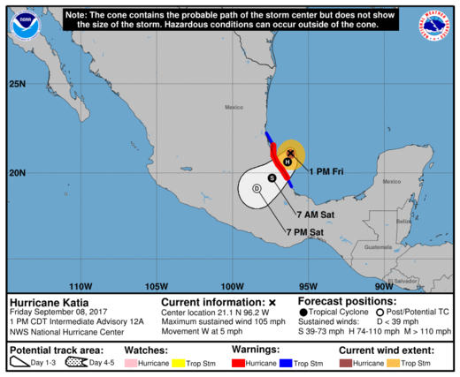
© NOAA

See also: Hurricanes may trigger earthquakes

https://www.sott.net/article/361486-5-4-magnitude-earthquake-strikes-near-San-Francisco-del-Mar-in-Mexico

Apocalyptic scenes from Mexico's earthquake; 3 days of mourning declared
RT
Sat, 09 Sep 2017 15:21 UTC
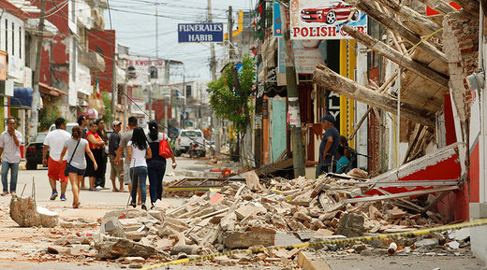
© Jorge Luis Plata / Reuters
Residents walk past a building destroyed in an earthquake that struck off the southern coast of Mexico, in Juchitan, Mexico September 8, 2017.

The number of people killed by the 8.2-magnitude quake that hit the southern coast of Mexico late Thursday has risen to at least 61, with witnesses saying they cannot remember an earthquake this terrible. Three days of mourning have been declared.
Mexican President Enrique Pena Nieto said the quake was "the largest registered in our country in at least the past 100 years." He said in a televised address Friday night that at least 45 people were killed in Oaxaca, 12 in Chiapas, and four in Tabasco.
But the actual death toll could be over 80, AFP reports, citing local state officials. Over 200 people were injured across Mexico, officials say.
A rescue operation is still under way, as emergency workers in the southern region, hit hardest by the quake, are hoping to pull more survivors from the ruins of Mexico's most powerful earthquake in a century.
Desperate searches for survivors are still going on in the rubble of houses, churches, and schools that were torn apart.
One Mexico City resident told ABC she sat vigil by the body of a loved one draped in a red shroud.
"We are holding vigil for her here because we went to purchase her coffin but there are none left because of how many people were killed," Alma Rosa said.
Oaxaca resident Rosa Esteva Luis said when she arrived at her mother's house, "she was crying."
"And my neighbor had the ceiling fall on top of his head, I don't know if he is alive," she said.
In Juchitan, local residents described the quake in apocalyptic terms.
"It was all horrific. Everything collapsed, everything," Maria Magdalena Lopez recalled. "The truth [is] I have no words to explain what happened. Look at my home, everything is destroyed."
In the Gulf coast state of Tabasco, two children were among the dead. One was crushed by a collapsing wall; another, an infant on a respirator, died after the quake triggered a power outage, AFP reports.
Rodrigo Soberanes, who lives near the town of San Cristobal de las Casas in Chiapas, told AP that his house "moved like chewing gum."
Around 428 homes were destroyed and 1,700 damaged in various cities and towns in Chiapas, the Interior Department said.
"Homes made of clay tiles and wood collapsed," Nataniel Hernandez, a human rights worker living in Tonala, Chiapas, told AP.
At least 36 bodies were pulled from the ruins of the hardest-hit city - Juchitan, Oaxaca - with roofs, cables, insulation, and concrete chunks scattered everywhere.
People gathered around Juchitan's wrecked town hall, where two policemen were trapped in the rubble. Rescuer workers managed to pull out one person and were still trying to save the other 18 hours after the quake, AFP reported.
"God, let him come out alive!" a woman cried, as four cranes and a dozen trucks removed what remained of the building's ruined wing.
Vidal Vera, 29, was one of 300 policemen digging through the rubble in an effort to find survivors.
"I can't remember an earthquake this terrible," he told AFP.
"The whole city is a disaster zone right now. Lots of damage. Lots of deaths. I don't know how you can make sense of it. It's hard. My sister-in-law's husband died. His house fell on top of him," he added.
"The priority in Juchitan is to restore water and food supplies and provide medical attention to those affected," Nieto tweeted on Saturday.
Mexico's seismology service estimated the quake at 8.2 magnitude. The US Geological Survey put it at 8.1.
The powerful jolt was felt as far north as Mexico City, 800 kilometers from the epicenter, triggering waves that reached as far as New Zealand, over 11,000 kilometers away.
Four people were also injured in neighboring Guatemala, where President Jimmy Morales ordered urgent humanitarian aid.
Pope Francis, at an open-air mass on Friday during a visit to Colombia, said he was praying "for those who have lost their lives and their families" in the disaster.

https://www.sott.net/article/361540-Apocalyptic-scenes-from-Mexicos-earthquake-3-days-of-mourning-declared

5.7 magnitude earthquake hits Mexican coast
Sputnik
Sun, 10 Sep 2017 08:02 UTC
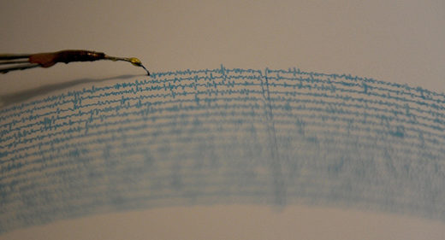
© AFP 2017/ PEDRO PARDO

A 5.7 magnitude earthquake occurred in waters off Mexico's Isthmus of Tehuantepec, the US Geological Survey (USGS) reported Sunday.
Quakes have been registered at 22:07 on Saturday local time (03:07 GMT on Sunday). The epicenter is located 80 kilometers (49) to southwest of the town of Paredon at the depth of 33 kilometers (about 32 miles).
No victims or damages have been reported yet.
The US Geological Survey said the magnitude 8.1 quake struck just before midnight on Thursday southwest from Pijijiapan in Mexico. It was described as the strongest quake to hit the country in a century.

https://www.sott.net/article/361583-5-7-magnitude-earthquake-hits-Mexican-coast

Shallow 5.9 magnitude earthquake at Reykjanes Ridge off Iceland
Earthquake Track
Sun, 10 Sep 2017 12:32 UTC
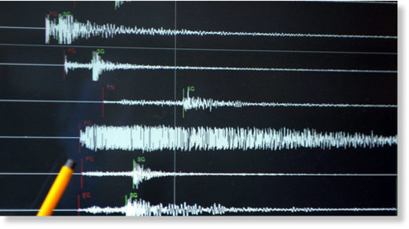

5.9 magnitude earthquake
2017-09-10 21:40:21 UTC
USGS page: M 5.9 - Reykjanes Ridge
USGS status: Reviewed by a seismologist
Reports from the public: 0 people
10 km depth

https://www.sott.net/article/361655-Shallow-5-9-magnitude-earthquake-at-Reykjanes-Ridge-off-Iceland

Guatemala suffers second earthquake in less than 72 hours
Earl Bousquet
teleSUR
Sun, 10 Sep 2017 15:30 UTC
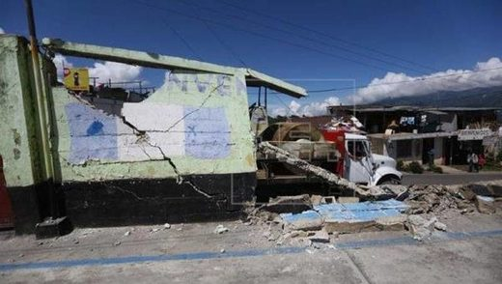
© EFE
More than six thousand people have been impacted by the first quake Tacana, Guatemala, September 8, 2017.

The western province of Huehuetenango was hit by a 7.7 magnitude quake on Thursday.
Guatemala has recorded a magnitude 5.4 earthquake without any casualties or damage, according to the National Institute of Seismology, Volcanology, Meterology and Hydrology (Insivumeh).
"Reports earthquake with magnitude of 5.4 and depth of 10 km 288 kilometers west of San Marcos."
The institute reported that the epicenter was 10 kilometers deep, located 288 kilometers west of the southwestern department of San Marcos, bordered by Mexico in the Pacific Ocean.
Thursday night's 8.1-magnitude earthquake in Mexico impacted on the lives of over six thousand people in neighbouring Guatemala, the National Coordinator for Disaster Reduction, Conred, reported.
Guatemala's western province of Huehuetenango which borders Mexico was also hit by a 7.7 magnitude quake in the aftermath and suffered major damage.
Some of the other regions hit by the tremors were Nueva Concepcion, Champerico, Retalhuleu, and the city of Escuintla.
An estimated 6,418 people have been affected in the western region of the central American country.
Hundreds of homes were damaged.

https://www.sott.net/article/361690-Guatemala-suffers-second-earthquake-in-less-than-72-hours

Southeast Idaho earthquake swarm continues as number of temblors surpasses 200 since September 2nd
Idaho State Journal
Sun, 10 Sep 2017 00:00 UTC
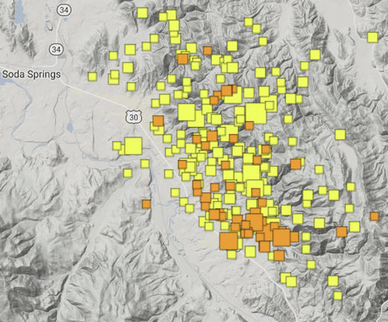
© University of Utah Seismograph Stations image
The colored squares show the epicenters of the 204 earthquakes that have occurred since Sept. 2 in Southeast Idaho, according to University of Utah Seismograph Stations.

The earthquake swarm in Southeast Idaho looked like it might be ending or at least slowing down on Thursday and Friday.
But then Saturday arrived and by day's end 19 quakes had struck.
There have been 34 more temblors so far Sunday, bringing the earthquake total since the swarm began on Sept. 2 to 204 quakes. All of the quakes have occurred in the Caribou County area east, southeast and northeast of Soda Springs.
They have been felt throughout Southeast Idaho and as far away as Logan, Ogden and Salt Lake City in northern Utah.
Earthquake experts say the worst-case scenario is that the swarm ends with a destructive 7.0 magnitude quake that will destroy buildings and kill people, but the chances of that are slim.
Dr. David Pearson, an Idaho State University geologist who studies earthquakes, said scientists who have researched some of the faults in Southeast Idaho have concluded that the 7.0 quake is possible at some point in the region's future, but the current earthquake swarm is not necessarily an indication that it will occur anytime soon.
Pearson said the faults in Southeast Idaho that produce earthquakes have not been extensively studied and this makes it difficult to determine when a destructive 7.0 earthquake could occur.
He said it's possible that one byproduct of the current earthquake swarm is that earthquake experts might start paying more attention to Southeast Idaho and its temblor potential. If more research on Southeast Idaho's seismic activity occurs, Pearson said there will be more information about what's going on under the Earth's surface here so that seismic activity such as earthquake swarms can be better explained.
There has been more extensive research done on northern Utah's earthquake potential and that region can expect a major earthquake sometime in the next 50 years, the experts say.
Pearson said Southeast Idaho's smaller population and lack of destructive earthquakes is why the region hasn't attracted more attention from those who study quakes.
The current earthquake swarm began on the night of Sept. 2 when 34 quakes occurred. Those were followed by another 34 quakes last Sunday, 28 on Monday, 20 on Tuesday, 25 on Wednesday, five on Thursday, five on Friday, 19 on Saturday and 34 so far Sunday. All 204 of the quakes were reported by University of Utah Seismograph Stations.
Thus far the most powerful temblor in the swarm was the second quake to occur. It was a 5.3 magnitude earthquake and struck at 5:56 p.m. Sept. 2. Authorities say it's been years since Southeast Idaho experienced a quake of 5.0 magnitude or greater. Such quakes can cause damage to houses and other buildings.
By comparison, a 7.0 magnitude quake would be at least 50 times bigger than the 5.3 magnitude temblor that hit Southeast Idaho last weekend.
The U.S. Geological Survey said that a 7.0 magnitude quake will inflict "considerable damage" on ordinary houses and buildings and will cause such structures to partially collapse. Such temblors will also cause chimneys, factory smoke stacks and walls to collapse, according to the USGA.
Fortunately no damage to structures or injuries to people have been reported as a result of any of the 204 earthquakes that have struck Southeast Idaho since Sept. 2. There have been reports that the quakes have caused some sink holes in the backcountry of Caribou and Bear Lake counties, but these have not been confirmed.
If a destructive 7.0 magnitude earthquake did occur, it could happen in the Caribou County area near the epicenters of the 204 quakes or it could happen elsewhere in the region where faults also exist, Pearson said.
He said other locations where the 7.0 quake could happen include Fremont, Teton, Oneida, Franklin and Bear Lake counties, southeast Bannock County and eastern Bonneville County.
Pearson said the current earthquake swarm could continue for another week but nothing's for certain and swarms have been known to continue for several weeks or even months in rare cases.
Pearson also said future seismic activity is possible in the Caribou County area because of the faults there.
But in regard to the current earthquake swarm, authorities say Southeast Idaho has never seen so many earthquakes in such a short time frame.
The strongest quake in state history was a 6.9 magnitude temblor that struck in 1983 between Mackay and Challis. That quake killed two children and damaged several buildings.
The good news is that the experts don't expect a big destructive quake to occur in Southeast Idaho during the next several days.
But more shaking from the earthquake swarm is a definite possibility.

https://www.sott.net/article/361702-Southeast-Idaho-earthquake-swarm-continues-as-number-of-temblors-surpasses-200-since-September-2nd

The Weather

Saint Martin is slammed by 185mph winds of Hurricane Irma
Kelly Mclaughlin
Daily Mail
Wed, 06 Sep 2017 20:24 UTC
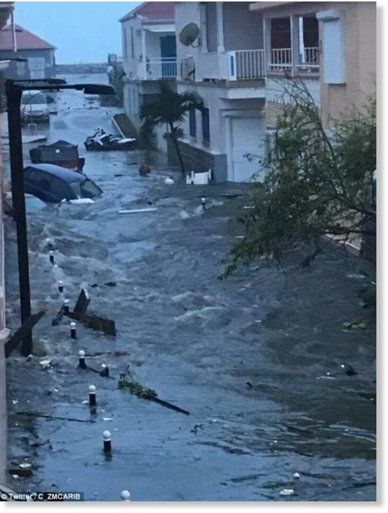
Dramatic pictures have started to emerge on social media showing the scale of the flooding on St Martin

St Maarten's famous international airport, Princess Juliana, has been destroyed by Hurricane Irma.
The storm ripped through the airport on Wednesday, with 185mph winds blowing over safety fences and battering nearby Maho beach.
Huge rocks smashed into planes, and boarding walkways were slammed to the ground by the downpour of rain and gusts of wind, which also brought loads of sand on to the runway.
Inside the airport, which lies on the Dutch side of Saint Martin island, the check-in lounge was flooded and walkways were damaged by the storm.
Parts of the building had broken off during the storm and were seen lying on the runway after the storm passed.
Photos of the damage were documented by a hurricane rescue team, who went in after the storm passed.

Princess Juliana Airport suspended all operations at the airport on Tuesday as a precaution before Hurricane Irma hit.
Michel Hyman, COO/Acting CEO of the airport, said in a statement: 'We regret any inconvenience this will cause, but must stress that the safety and security of all is priority number one at SXM Airport.'
'We will continue to closely monitor the developments of Hurricane Irma as it passes over our area and keep all our personnel, users and stakeholders informed of any further developments as these occur, via the various media outlets,' stated Hyman.
Winair canceled its services on Tuesday and Wednesday, saying it would work to re-book customers' flights at no additional cost.
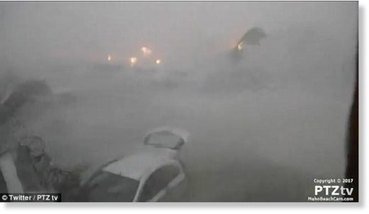
Princess Juliana Airport, pictured in the midst of the storm, suspended all operations at the airport on Tuesday as a precaution before Hurricane Irma hit

Hurricane Irma has caused torn off rooftops and knocked out all electricity across Saint Martin, as well as on the French island of Saint Barthelemy.
Banks on St Martin closed on Tuesday ahead of the storm, while WTN-Cable management dismantled its sites to avoid irreparable damage.
All sites will return to normal after the storm passes and authorities give the go-ahead for people to move around the island.
France has requisitioned planes and sent in emergency food and water rations.
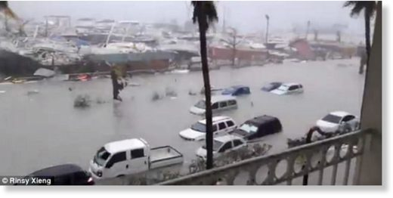
Social media videos show how the hurricane lashed the coastline of Saint Martin overnight with cars submerged in water. This picture is believed to have been taken at the Beach Plaza hotel on the island

President Donald Trump owns a property in St Martin - Le Chateau des Palmiers, which is currently up for sale.
It is unknown if his property was damaged by the storm.
Meanwhile, a Dutch navy spokeswoman said that marines who flew to three islands hammered by Hurricane Irma have seen a lot of damage, but have no immediate reports of casualties.
Navy spokeswoman Karen Loos says that some troops were able to send images of destruction from St. Maarten and another island, St. Eustatius.
Loos says, 'You do see there is a lot of damage. Trees, houses, roofs that are blown out. A lot of water, high water.'
She says the extent of the damage elsewhere on the island is not yet clear.
The first of two Dutch naval vessels heading for the islands is expected to arrive at 8pm local time in St. Maarten.
The regional authority for Guadeloupe and neighboring islands said in a statement on Wednesday that the fire station in Saint Barthelemy is under 1 meter (more than 3 feet) of water and no rescue vehicles can move.
It said the government headquarters Saint Martin is partially destroyed and the island is in a total blackout.
Electricity is also partially down on the larger island of Guadeloupe, where the threat receded despite danger of heavy flooding.
French minister for overseas territories Annick Girardin expressed fear 'for a certain number of our compatriots who unfortunately didn't want to listen to the protection measures and go to more secure sites.'
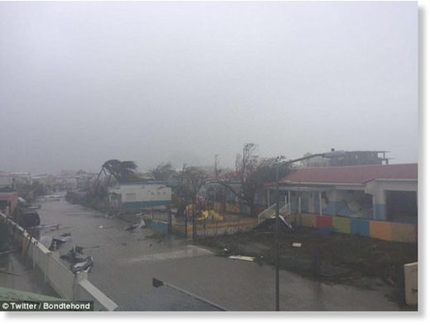
Hurricane Irma has caused torn off rooftops and knocked out all electricity across Saint Martin (pictured), as well as on the French island of Saint Barthelemy

She added: 'We're preparing for the worst.'
Antigua and Barbuda Prime Minister Gaston Browne said his twin-island nation appears to have weathered its brush with Hurricane Irma.
He said there were no deaths in Antigua and preliminary reports indicated there were no deaths in Barbuda despite widespread reports of damaged buildings and downed trees. He said he plans to visit as soon as possible.
Hurricane Irma is roaring along a path pointing to Puerto Rico, the Dominican Republic, Haiti and Cuba before possibly heading for Florida over the weekend.
President Donald Trump declared emergencies in Florida, Puerto Rico and the US Virgin Islands, and authorities in the Bahamas said they would evacuate the residents of six islands at the southern end of the island chain amid fears the hurricane is hurtling towards the US east coast.
A mandatory evacuation is under way in the Florida Keys.
National Weather Service Director Louis Uccellini said that Hurricane Irma is so record-breaking strong it's impossible to hype.
Uccellini said on Wednesday that he's concerned about Florida up the east coast to North Carolina, starting with the Florida Keys.
He warns that 'all the hazards associated with this storm' are going to be dangerous.
Hurricane expert Kerry Emanuel of MIT calculates that Irma holds about 7 trillion watts - about twice the energy of all bombs used in World War II.
The Category 5 storm made a direct hit Wednesday on Saint Martin, the island where the Dutch territory of St Maarten is located. Some 100 Dutch marines flew to the islands on Monday to prepare for the hurricane.
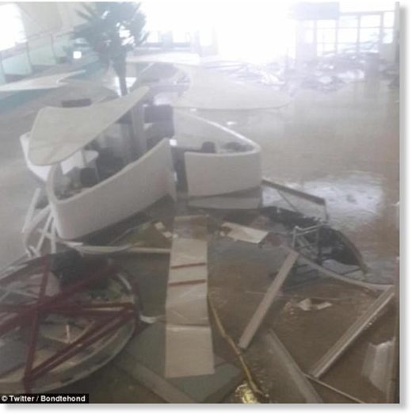
Huge rocks smashed into planes, and boarding walkways were slammed to the ground by the downpour of rain and gusts of wind, which also brought loads of sand on to the runway

https://www.sott.net/article/361311-Saint-Martin-is-slammed-by-185mph-winds-of-Hurricane-Irma

Katia becomes third hurricane to threaten US in six days
Shehab Khan
The Independent (UK)
Wed, 06 Sep 2017 21:32 UTC
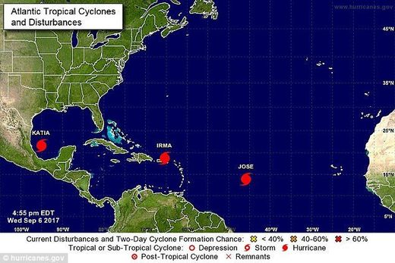
© hurricanes.gov
Tropical storm Katia strengthened into a hurricane off the Mexican coast on Wednesday - marking the first time since 2010 there has been a trio of hurricanes around the Atlantic region.

Winds of up to 75 miles per hour are expected
A third hurricane is set to threaten the US in the space of six days.
Katia, a storm off the Mexican coast, has strengthened into a hurricane, the US National Hurricane Center (NHC) said.
It is 185 miles (295 km) east of Tampico, Mexico, and has maximum sustained winds of 75 miles per hour (120 kph).
In the next 48 hours some additional strengthening is also forecast, the NHC added.
Models so far show it remaining in the southern Gulf in the coming days.
The news comes as tropical storm Jose was upgraded to a hurricane in the Atlantic, far east of Hurricane Irma, which is currently heading towards Florida.
Jose had been expected to become a hurricane and was following Irma in a path towards the Caribbean.
It is too early to determine if Jose might ultimately make landfall in the Caribbean, or in the Americas, as weather projections are difficult when storms are so far out.
Hurricane Irma on the other hand has been setting records with sustained wind speeds of 185 miles per hour for more than 24 hours. In doing so became the only Atlantic hurricane to sustain that powerful wind speed for so long.
Irma has clobbered hit islands with pounding winds, rain and surging surf and officials in Florida have called for evacuations ahead of the storm's expected landfall there.
Comment: While climate scientists are now saying Harvey "should serve as a warning", they are not considering the importance of atmospheric dust loading and the winning Electric Universe model in their research. Such information and much more, are explained in the book Earth Changes and the Human Cosmic Connection by Pierre Lescaudron and Laura Knight-Jadczyk.
The accumulation of cometary dust in the Earth's atmosphere plays an important role in the increase of tornadoes, cyclones, hurricanes and their associated rainfalls, snowfalls and lightning. To understand this mechanism we must first take into account the electric nature of hurricanes, tornadoes and cyclones, which are actually manifestations of the same electric phenomenon at different scales or levels of power.
Increasing cometary and volcanic dust loading of the atmosphere (one indicator is the intensification of noctilucent clouds we are witnessing) is accentuating electric charge build-up, whereby we can expect to observe more extreme weather and planetary upheaval as well as awesome light shows and other related mysterious phenomena.
See also: Study: Tornado outbreaks are increasing - but scientists don't understand why. A coauthor of this paper states "What's pushing this rise in extreme outbreaks is far from obvious in the present state of climate science."

https://www.sott.net/article/361329-Katia-becomes-third-hurricane-to-threaten-US-in-six-days

'Barbuda is literally rubble': Shocked PM says Hurricane Irma destroyed 90% of homes on tiny Caribbean island
RT
Thu, 07 Sep 2017 00:44 UTC
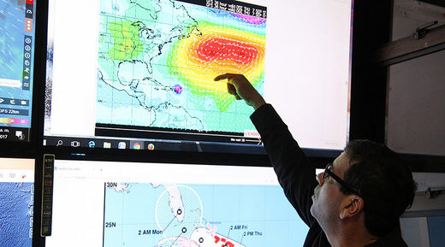
© Ricardo Rojas / Reuters
A member of the Emergency Operations Committee (COE) monitors the trajectory of Hurricane Irma in Santo Domingo, Dominican Republic, September 6, 2017.

Houses and infrastructure on Barbuda have been "totally demolished," Antigua and Barbuda PM told media following a helicopter trip to the Caribbean island. The island of 1,600 residents went radio silent for over twelve hours, causing wild speculations over their fate.
Conflicting reports emerged in the vacuum of information and the absence of direct communication with the island. Some claimed that 1,000 people had died but this was quickly debunked, with calls for people to wait for official confirmation before retweeting carelessly and generating unnecessary panic and dismay.
The prime minister of Antigua and Barbuda, Gaston Browne, has confirmed one fatality after making a roundtrip to the island on a helicopter.
"There has been a fatality. An infant died as a result of their mother trying to escape a damaged property. We are not too sure of the cause of death," Browne told local ABS news in an interview.
Browne said the scenes he witnessed on the island were "heart-wrenching."
"If I was a crying man, I would have cried," Browne told ABS. "[It was] one of the worst feelings I have ever felt in my entire life... Absolute devastation, this is no hyperbole."

Browne waited out the storm on a neighboring island at the request of his staff before flying in via helicopter to assess the damage first hand.
"Even though they had a backup ham [radio] system and a satellite phone, they were destroyed. They had absolutely no way to communicate with us," he said.
While the PM was on the ground, meeting with survivors, a second aircraft conducted a preliminary assessment of the damage inflicted.
"The entire housing stock was damaged. The cost to repair the infrastructure will be no less than $150 million," Browne said.
"Barbuda is literally rubble," he added. "This rebuilding initiative will take years."
The official praised the level of preparation ahead of the hurricane which he claimed was directly responsible for the near total lack of fatalities in spite of the widespread devastation which he estimates has left roughly 60 percent of the population homeless.
Browne promised to do "whatever it takes to accommodate the Barbudan people," suggesting renting private property and the old airport terminal building to house those displaced by the destructive hurricane.
He also confirmed that, as of Wednesday evening, there was no mandatory evacuation order ahead of Hurricane Jose but added that people should use common sense and find shelter or evacuate as they see fit.
According to 2011 Census data cited by ABC the island's population is approximately 1,600 people, though Browne estimates the number at closer to 1,800.

https://www.sott.net/article/361330-Barbuda-is-literally-rubble-Shocked-PM-says-Hurricane-Irma-destroyed-90-of-homes-on-tiny-Caribbean-island

Tropical triple threat: Hurricanes Katia & Jose follow on the heels of Irma
RT
Thu, 07 Sep 2017 14:05 UTC
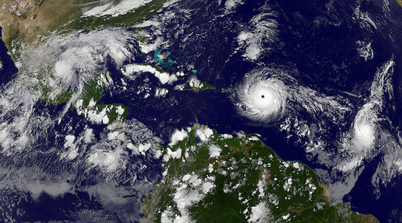
© NASA
Hurricanes Katia and Jose

Two other giant storms - Katia and Jose - have grown to hurricane levels, and now trail the calamitous Category 5 Hurricane Irma, which has battered the Caribbean and is headed toward the southern coast of Florida.
Katia, a Category 1 hurricane as of Wednesday evening, is in the Gulf of Mexico and is expected to make landfall in Mexico late Friday or early Saturday.
The storm is forecast to produce up to 10 inches of rain, with the possibility of 15 inches in northern Veracruz, according to the National Hurricane Center.
"This rainfall may cause life-threatening flash floods and mudslides, especially in areas of mountainous terrain," NHC said.
For comparison, Hurricane Harvey unloaded over 50 inches of rain east of Houston, Texas last week.
Katia's maximum sustained winds are 75mph (120 km/h), compared with Irma's 185 mph (295 km/h), which makes the latter one of the strongest Atlantic hurricanes in history. Hurricane Katrina in 2005 had 175 mph winds.
Jose, like Katia, is a Category 1 hurricane with 75 mph winds. It is in the Atlantic, moving behind Category 5 Hurricane Irma, also in the northwest direction. However, Jose is unlikely to make landfall.

With the three hurricanes on the map simultaneously, all eyes are on Irma, which is expected to bring a 20-foot storm surge and 20 inches of rain.
On Wednesday, it slammed the island of Barbuda before hitting St. Martin and Anguilla.
"Barbuda is literally rubble," Prime Minister Gaston Browne of Antigua and Barbuda told ABS TV/Radio Antigua.
Water and communication on the island have been cut off, Browne said. "It is just a total devastation."
About 1,800 people live on Barbuda.
Destruction on Barbuda was "upwards of 90 percent," Charles Fernandez, minister of foreign affairs and international trade for Antigua and Barbuda, told ABS.

https://www.sott.net/article/361345-Tropical-triple-threat-Hurricanes-Katia-Jose-follow-on-the-heels-of-Irma

Georgia gets its first snowfall three months before the start of winter
Agenda.Ge
Thu, 07 Sep 2017 14:26 UTC
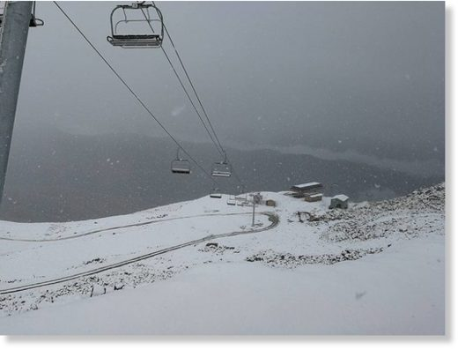
© Nick Phaliani
Tetnuldi is the newest ski resort in Georgia

The newest of Georgia's winter resorts, Tetnuldi in Svaneti region in the western part of the country, has experienced its very first snowfall this year today even though winter is almost three months away.
The first snowfall at Tetnuldi has been described as a light dusting and is believed not to last long, but in the coolest months snowfall can be very high and can reach several metres.
Weather experts forecast slushy snow may fall in other mountainous regions of Georgia in the coming days, but despite this, citizens are being advised not to dig out their winter coats just yet as daytime temperatures around the country are set to rise.
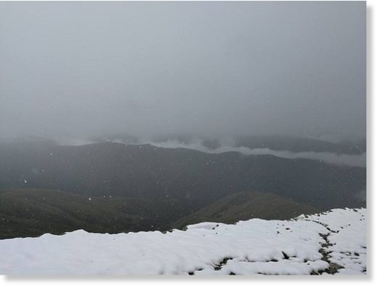
First snow in Tetnuldi, Svaneti, Georgia

Tetnuldi ski resort opened two years ago after the first phase of the area's development ended in January of 2015.
Tetnuldi is a cut above other ski resorts in Georgia and the wider region as it has the longest trails with the biggest vertical drops in the South Caucasus.
Once fully developed, the Georgian government expects Tetnuldi be the best ski resort in Eastern Europe.
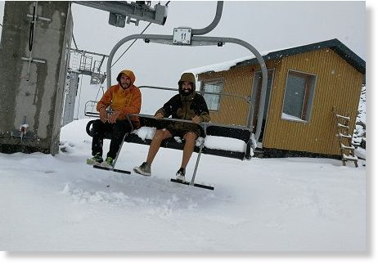
© Nick Phaliani

https://www.sott.net/article/361351-Georgia-gets-its-first-snowfall-three-months-before-the-start-of-winter

Category 5 Hurricane Irma stronger than all of 2017's other eight Atlantic storms combined
Justin Miller
The Daily Beast
Wed, 06 Sep 2017 21:15 UTC
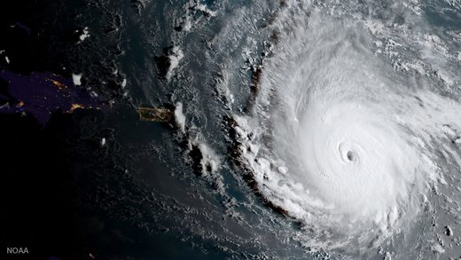
The Category 5 storm is breaking records and headed towards Puerto Rico and the Bahamas. Florida may be next.

Hurricane Irma's winds are stronger than if you were to add up all of the winds of the prior eight storms Atlantic storms together at maximum intensity.
That's just one shattering measure of the storm's strength from meteorologist Phil Klotzbach, research scientist at Colorado State University's Department of Atmospheric Science. Irma's 185 mph winds make it the strongest storm on record in the Atlantic Ocean outside of the Caribbean and Gulf of Mexico, according to Klotzbach's research, which he shared with The Daily Beast.
"Most of the other storms this season were pretty weak and short-lived. While Harvey was intense, it was intense for a short time period before making landfall," Klotzbach said.
Irma's wind speeds are tied with the second-strongest maximum winds of all time for an Atlantic hurricane, matching a 1935 storm in the Florida Keys and Hurricanes Gilbert (1988) and Wilma (2005). Only one hurricane, Allen in 1980, has recorded stronger winds, at 190 mph. Irma has broken Allen's record for sustained winds though.
The intense winds make Irma a Category 5 storm, the most severe on the hurricane scale. Hurricane Harvey, which flooded Houston and destroyed swaths of Texas, was a Category 4.Irma grew so powerful so quickly to due to a combination of very warm water, high levels of mid-level relative humidity, and vertical wind condition.
"A hurricane's primary fuel source is warm ocean water, so warmer water provides more fuel for the storm," Klotzbach said. "Anomalously high mid-level relative humidity provides the moisture necessary for thunderstorm formation, which are the building blocks of hurricanes."The tropical Atlantic, stretching from the west coast of Africa (where hurricanes form) to the Caribbean, has been warmer in recent years, but Klotzbach said it's "too early to say conclusively that it's climate-change related."
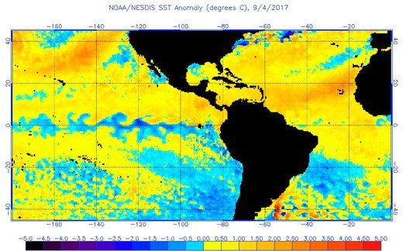

Irma destroyed 90 percent of the Caribbean island of Barbuda, the prime minister of Antigua and Barbuda said Wednesday night. Barbuda is home to about 1,600 residents.
The National Weather Service forecasts Irma's "extremely dangerous core" to pass just north of Puerto Rico on Wednesday night, pass near or just north of the coast of the Dominican Republic and Haiti on Thursday, and reach the Turks and Caicos and southeastern Bahamas by Thursday evening.
Irma's final destination appears to be Florida, with its 20 million residents. The National Hurricane Center forecasts tropical-storm force winds beginning to buffet the state on Sunday night with hurricane-force winds expected Monday.
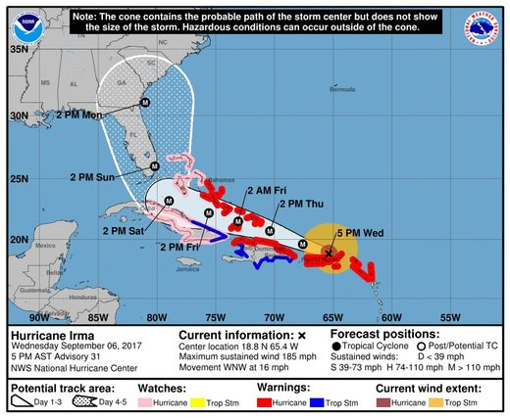

"There was also a fairly marked shift in the forecast track guidance and now puts the highest threat along the east coast of Florida or potentially into the Carolinas," Klotzbach said. "NHC has responded by shifting their track somewhat further east but not as far as some of the models have shifted. It still remains to be seen if this forecast track shift is going to continue, however."
The National Hurricane Center projects Irma will make landfall as a Category 4 storm, which would be the strongest storm to hit Florida since Charlie in 2004. No Category 5 storm has hit Florida since 1992's Andrew, which killed 62 people.
The powerful winds of Category 4 and 5 storms are capable of destroying framed homes and snapping trees, according to the National Hurricane Center. "Fallen trees and power poles will isolate residential areas. Power outages will last for weeks to possibly months," NHC warns. "Most of the area will be uninhabitable for weeks or months."
Officials ordered mandatory evacuations in the Florida Keys and Broward County, north of Miami, on Wednesday. Miami-Dade County has not ordered evacuations yet, though the mayor warned people in low-lying areas and islands may need to leave.
"The storm's slowing down, giving us a little bit more time," Mayor Carlos Gimene said.
Already though two Category 2 hurricanes have formed in the hemisphere: Katia in the Gulf of Mexico, expected to hit Mexico, and Jose in the Atlantic.

https://www.sott.net/article/361352-Category-5-Hurricane-Irma-stronger-than-all-of-2017s-other-eight-Atlantic-storms-combined

Category 5 Irma hits Leeward Islands at peak strength, eye misses Puerto Rico, Virgin Islands
Bob Henson and Dr. Jeff Masters
Wundergroud
Wed, 06 Sep 2017 16:42 UTC
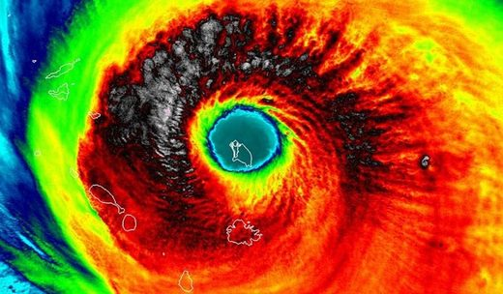
© UW-Madison/CIMSS
Above: VIIRS infrared image of Hurricane Irma taken at 1:35 am EDT Wednesday, September 6, 2017. At the time, the island of Barbuda was in the eye, and Irma was a Category 5 storm with 185 mph winds.

Hurricane Irma smashed into the small Lesser Antilles islands of Barbuda (population 1,638), Saint Barthelemy (population 9,000), Anguilla (population 15,000), and Saint Martin/Sint Maarten (population 8,000/33,000) early Wednesday as a mighty Category 5 hurricane with 185 mph winds. As the front southwestern eyewall of Irma hit, Barbuda reported sustained winds of 118 mph, gusting to 155 mph, before the instrument failed. The minimum pressure in the eye was 916 mb on Barbuda and St. Barthelemy. Preliminary reports from these islands indicate heavy wind and storm surge damage occurred. On Saint Martin, storm surge flooding to rooftop level was observed. Irma brought a storm surge of 7.95 feet (2.42 meters) to Barbuda, according to a Wednesday afternoon blog post by storm surge scientist Dr. Hal Needham. Barbuda has not been heard from yet.
A hurricane with top winds of 185 mph has never been recorded in these islands, and Irma's landfall intensity of 185 mph winds in the Leeward islands is tied with the 1935 Florida Keys Labor Day Hurricane as the highest landfall intensity on record for an Atlantic hurricane (third place globally.) The most recent close analog for Irma may be Hurricane Hugo (1989), which tore through the Leewards and struck Puerto Rico as a Category 4 storm, causing $3 billion in damage (1989 dollars) and 72 deaths.

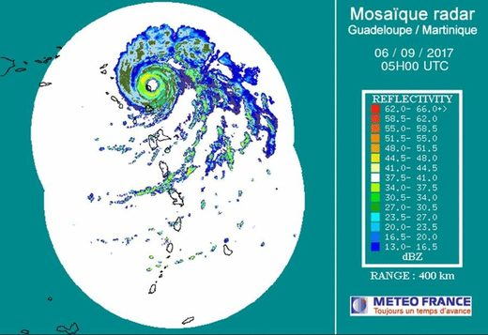
© Meteo France
Figure 1. Radar image of Irma taken at 1 am EDT September 6, 2017. The island of Barbuda is in the southwestern portion of the eye. A long loop of the radar (courtesy Brian McNoldy) shows the track of Irma over Barbuda and the Leeward Islands.

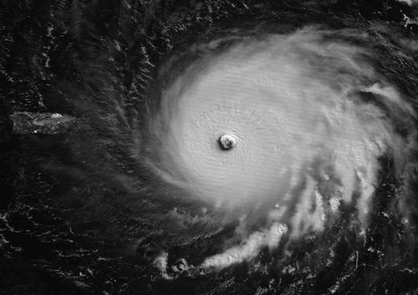
© NASA
Figure 2. Hurricane Irma as seen in moonlight by the VIIRS instrument on the Suomi satellite at approximately 3 am EDT Wednesday, September 6, 2017. Barbuda was in the southeastern eyewall of Irma at this time. Puerto Rico is visible at the left of the image.

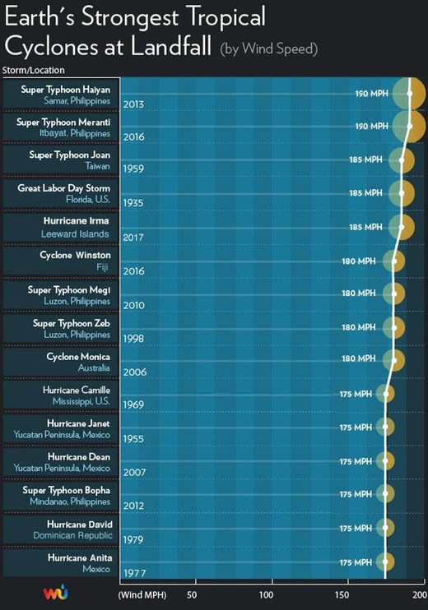
Figure 3. Irma's landfall intensity of 185 mph winds in the Leeward islands is tied with the 1935 Florida Keys Labor Day Hurricane as the highest landfall intensity on record for an Atlantic hurricane, and is in third place globally.

Next targets: British Virgin Islands, U.S. Virgin Islands, and Puerto Rico
On Wednesday afternoon, Irma will make a direct hit on the British Virgin Islands, including Virgin Gorda (population 4,000), and Tortola (population 9,000.) The southern eyewall of Irma is also likely to affect the island of Saint John (population 4,000) in the U.S. Virgin Islands. A personal weather station on the south shore of St. Thomas measured sustained winds of 94 mph at 12:33 pm Wednesday. The island of Saint Thomas (population 52,000) may barely miss the eyewall of Irma, but northeastern portions of the island are still likely to receive sustained Category 1 hurricane winds of 75 - 90 mph. The same holds true for Puerto Rico's Culebra Island. The extreme northeast corner of Puerto Rico should see slightly lower winds, near 60 - 80 mph.
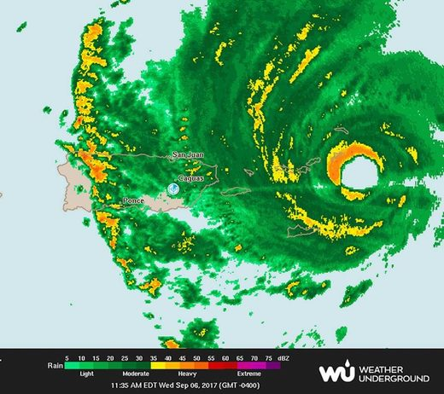
Figure 4. Radar image of Irma from the Puerto Rico radar at 11:35 am EDT September 6, 2017. The northwest eyewall was over the British Virgin Islands.

Longer-range outlook for Irma: Cuba, the Bahamas, and Southeast U.S.
Computer model guidance has begun to consolidate somewhat on Irma's future during the period from Saturday onward, but there remains major uncertainty on exactly where Irma will track. Our top three track models-the European, GFS, and UKMET models-continue to agree strongly that Irma will continue on a west-northwest track through at least Friday. NHC predicts that Irma will still be a Category 5 hurricane through at least Friday morning. By late Thursday, Irma will likely be in or near the Southeast Bahamas, which are under a Hurricane Warning, with a Hurricane Watch for the Central Bahamas as of Wednesday morning. Some of the islands of the Southeast Bahamas may take a direct hit from Irma, and other islands may wind up in the dangerous right-hand side of the storm. Irma has the potential to be a devastating storm for The Bahamas, especially its southern islands, and residents should rush any needed preparations to completion.
By Saturday, there is fairly strong model agreement that Irma will be located somewhere between the western Bahamas and Cuba, still on its west-northwest track. Irma will be paralleling the north coast of Cuba, and it is possible Irma's center will move just inland along the coast for some period of time; parts of the north coast of Cuba are within the "cone of uncertainty" in the official NHC forecast. Residents of Cuba will need to pay very close attention to Irma's track. The eastern two-thirds of Cuba was under a Hurricane Watch as of Wednesday morning. Irma is not expected to cross Cuba and move into the Caribbean.
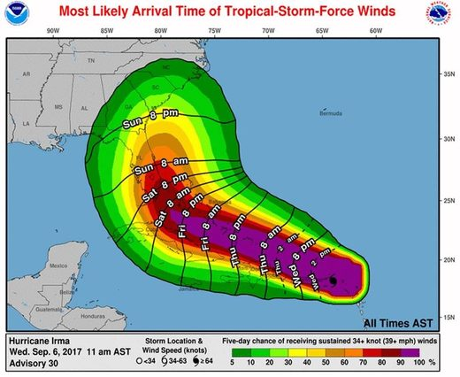
© National Hurrican Center
Figure 5. Most likely arrival time of tropical-storm-force winds from Irma, as of the 11 am EDT Wednesday, September 6, 2017 advisory from NHC.

Models have been very consistent that Irma will take a sharp turn toward the north-northwest during the weekend, working its way around the west end of an upper-level ridge that has been steering Irma all week. The crucial question is exactly where and when Irma will take this right-hand turn, as that will play a huge role in possible impacts to the Southeast U.S. coast. Our top models shifted eastward on Tuesday night in their predictions of where the right-hand turn will occur, and the consensus is now that Irma is most likely to track from south to north either across the Florida Peninsula or just east of it, perhaps remaining near the coastline until moving further inland somewhere from Georgia to North Carolina. Irma is not expected to track sharply away from the Southeast U.S. coastline. A track along or just off the west coast of Florida is still possible. None of our reliable models bring Irma any further west than the Florida Panhandle, so the chance of Irma moving deeply into the central or western Gulf is increasingly remote. A track that curves north and stays just east of Florida is also possible; such a track could still bring Irma into the East Coast at a point further north early next week. Figures 6, 7 and 8 below show the range of possibilities in ensemble model guidance from Tuesday night (ensemble models include a number of parallel forecasts that reflect the uncertainty in a given weather situation).
In short, computer guidance is in strong agreement that Irma will make at least one landfall somewhere from Florida to North Carolina during the weekend or early next week. The official NHC forecast track as of 11 am Wednesday brings Irma from near Miami to near Daytona Beach from Sunday morning to Monday morning. The 12Z Tuesday run of the GFS model predicts that Irma will hit Miami on Sunday afternoon, then make a second landfall near the Georgia/South Carolina border on Monday afternoon, with both landfalls occurring with at least Category 4 strength.
The entire Florida peninsula and southeast Georgia are within the five-day cone of uncertainty in the official NHC forecast, and all residents of these areas should pay especially close attention to the progress of Irma. Residents of southeast Florida need to be especially vigilant.
Intensity and storm surge
By the time of its turn, Irma is still predicted to be a Category 4 hurricane by NHC, and the GFS and European forecast models imply that Irma could be close to Category 5 strength, especially if its center does not move onshore across northern Cuba. Wind shear is predicted to remain low to moderate along Irma's path until Saturday, and Irma will be passing over waters that are as warm or slightly warmer than its current environment, so there is nothing that would be expected to cause major weakening of Irma other than potential land interactions, especially with Cuba. As Irma moves northward, increasing wind shear and interactions with land will likely begin to weaken Irma. However, Irma is expected to remain a major hurricane well after its northward turn, even if its center moves over the Florida peninsula and especially if the center remains just off the coast. The official NHC forecast as of 11 am Wednesday has Irma as a Category 3 storm on the east-central Florida coast on Monday morning.
Because of Irma's long life and its extreme strength, Irma will be pushing a tremendous amount of water through the Bahamas in the form of high waves and storm surge. Even if Irma's winds weaken and its Saffir-Simpson category drops, Irma could still be capable of extreme storm surge, depending on its track and the geography of its landfall location(s). Storm surge expert Dr. Hal Needham noted in a blog post Wednesday: "The region from northeast Florida (St. Augustine) through all of the Georgia coast and southwest South Carolina is particularly vulnerable to storm surge, whether or not Irma makes a direct landfall in that region."
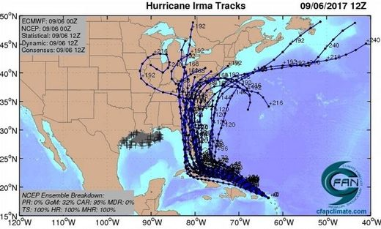
© CFAN
Figure 6. The 20 track forecasts for Irma from the 0Z Wednesday, September 6, 2017 GFS model ensemble forecast.

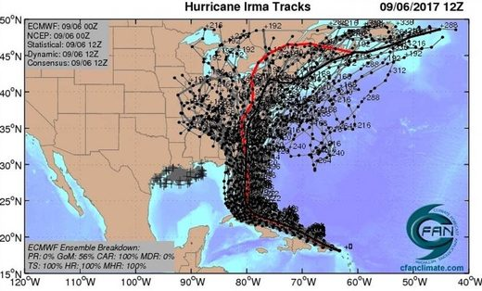
© CFAN
Figure 7. The 0Z September 6, 2017, track forecast by the operational European model for Irma (red line, adjusted by CFAN using a proprietary technique that accounts for storm movement since 0Z Wednesday), along with the track of the average of the 50 members of the European model ensemble (heavy black line), and the 50 track forecasts from the 0Z Wednesday European model ensemble forecast (grey lines).

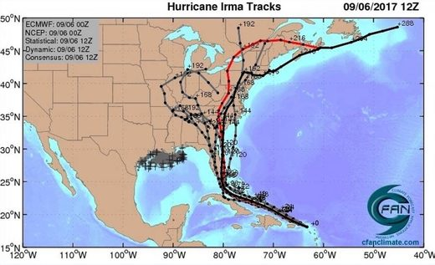
© CFAN
Figure 8. The 0Z September 6, 2017, track forecast by the operational European model for Irma (red line, adjusted by CFAN using a proprietary technique that accounts for storm movement since 0Z Wednesday), along with the track of the average of the 50 members of the European model ensemble (heavy black line), and the track forecasts from the "high probability cluster" (grey lines)-the four European model ensemble members that have performed best with Irma thus far. All of these variations bring Irma very close to the Miami-Fort Lauderdale-Palm Beach corridor.

Meanwhile, we have Jose and Katia
Two other tropical storms have developed since Tuesday morning. Tropical Storm Jose bolted to near-hurricane strength overnight, with top sustained winds of 70 mph as of 11 am Wednesday. Located about 1100 miles east of the Lesser Antilles, Jose is headed at 17 mph on a steady west-northwest track, steered by the same ridge that is helping to direct Irma. On its current track, Jose would reach the northern Leeward Islands by Saturday, but the ridge is predicted to weaken enough by Saturday to allow Jose to arc just northeast of the islands. Conditions are favorable for Jose to strengthen into a hurricane by later Wednesday, and it could approach Category 3 strength by late in the week. About 25% of the European model ensemble members bring Jose into the northern Leeward Islands, but all of the GFS ensemble members keep Jose north of the islands.
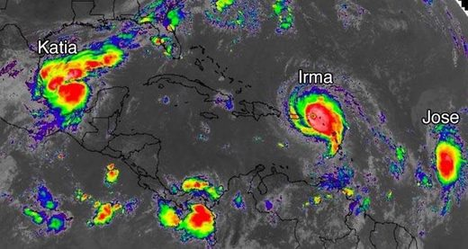
© NASA/MSFC Earth Science Branch
Figure 9. Infrared satellite image of Katia, Irma, and Jose as of 1530 (11:30 am EDT) Wednesday, September 6, 2017.

Tropical Storm Katia was christened by NHC at 5 am EDT Wednesday, and its estimated top winds had increased to 45 mph as of 11 am EDT. Located in the Bay of Campeche about 175 miles north of Veracruz, Mexico, Katia is embedded in a very moist environment with numerous showers and thunderstorms along and south of a frontal zone (see Figure 9), and the storm's core has become gradually more organized. NHC predicts that Katia will become a hurricane by Friday atop the bay's very warm waters (30-31°C or 86-88°F). Wind shear will be dropping from about 10-15 knots to around 5-10 knots by Friday, which also supports development. Our top track models and the Euro and GFS ensembles are unanimous in drifting Katia for a couple of days before driving it southwestward into the Mexican coast this weekend. Extremely heavy rains of 10 - 20" are possible along parts of the northeast Mexican coast, especially in northern Veracruz, as Katia approaches and moves inland.

https://www.sott.net/article/361395-Category-5-Irma-hits-Leeward-Islands-at-peak-strength-eye-misses-Puerto-Rico-Virgin-Islands

Hurricanes Irma, Jose, Katia threatening landfall is 'unparalleled' in modern times, tropical storms expert says
Will Worley
The Independent (UK)
Fri, 08 Sep 2017 11:07 UTC
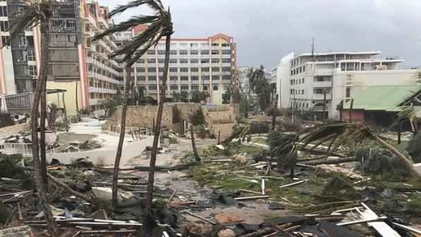
© Jonathan Falwell/AP
Irma wreaks destruction on St Martin

Islanders are bracing for more storm damage
The appearance of three strong hurricanes in the Atlantic basin which all threaten land is "unparalleled" in modern times, a tropical storms expert has said.
Hurricane Irma has already caused major damage in the Caribbean and is expected to hit southern Florida, while Hurricane Katia is menacing eastern Mexico, and Hurricane Jose could hit Antigua and Barbuda, which suffered major damage just days ago under Irma.
The last time there were three hurricanes in the Atlantic basin simultaneously was 2010, meteorologists said. Including this year, there are only six examples of simultaneous hurricanes on record, according to the Met Office.
But it is the first time all three have threatened land, according to Eric Blake, a scientist at the National Hurricane Centre.
"Never seen anything like this in the modern record," he said on Twitter.
"Three separate hurricane watches at once for the Atlantic? Unparalleled here and totally ridiculous given Irma."
Compared to the 2010 storms, Karl, Igor and Julia, Mr Blake said: "Julia was nowhere near land. Never a threat. Irma likely to do 100 times more damage than Igor/Karl."
Images shared comparing the hurricanes were inaccurate, Mr Blake said, because the tracks of the storms were different, meaning Irma, Katia and Jose are much more threatening to humans.
"We are in peak hurricane season," said Met Office spokesman Graham Madge.
"The appearance of several hurricanes at the same times isn't unknown, and there is a meteorological term, fujiwhara, for them dancing around and interacting with each other."
Prior to 2010, there were three or more simultaneous Atlantic hurricanes in 1967, 1980, 1995 and 1998.
Hurricane Irma, which caused severe damage to parts of the Caribbean, has weakened to a Category Four storm, but is still described as "very dangerous", with winds of up to 155mph.
It is expected to maintain its strength as it approaches the Turks and Caicos and Bahamas, then Florida.
State governor Rick Scott said: "This storm has the potential to catastrophically devastate our state and you have to take this seriously."
Half a million Floridians have been evacuated.
Meanwhile, it is feared Hurricane Jose, a Category Three storm, could bring further devastation to areas already battered by Irma.
Comment: Hurricanes Irma and Jose have set a record by being the first two hurricanes with speeds topping 150mph to appear at the same time.

"We are very worried about Hurricane Jose," Gaston Browne, prime minister of Antigua and Barbuda, told The Washington Post.
He said around 60 per cent of Barbuda's 2,000 inhabitants were homeless because of the damage wrought by Irma.
Residents are attempting to evacuate the island but there are few boats to help move them.
And the category one Hurricane Katia is in the Gulf of Mexico and menacing the country's eastern seaboard.
It is expected to hit the state of Veracruz on Saturday. Experts are concerned the hurricane, currently generating 80mph winds, could gain strength by the time it makes landfall.
Katia has "worrying characteristics" because it is very slow-moving and could dump a lot of rain on areas that have been saturated in recent weeks, according to Luis Felipe Puente, head of Mexico's national emergency services.

https://www.sott.net/article/361478-Hurricanes-Irma-Jose-Katia-threatening-landfall-is-unparalleled-in-modern-times-tropical-storms-expert-says

Hurricane Jose strengthens to become an 'extremely dangerous' Category 4 storm
Mary Kekatos
Daily Mail
Sat, 09 Sep 2017 09:05 UTC
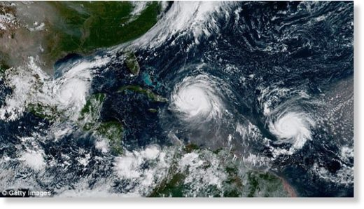
Hurricane Jose strengthened to an 'extremely dangerous' Category 4 storm on Friday with maximum sustained winds of 150mph. This image from the National Oceanic and Atmospheric Administration shows Hurricane Katia (left), Hurricane Irma (center), and Hurricane Jose (right) on Thursday in the Atlantic Ocean

Hurricane Jose strengthened to an 'extremely dangerous' Category 4 storm on Friday with maximum sustained winds of 155mph.
According to the National Hurricane Center, the storm was 265 miles east-southeast of the northern Leeward Islands at a rapid 18mph.
With winds picking up speed quickly, forecasters fear the storm may be on the brink of reaching Category 5 strength.
Jose is expected to pass near or east of the northeastern Leeward Islands on Saturday and is currently threatening several islands that were seriously damaged by Hurricane Irma.
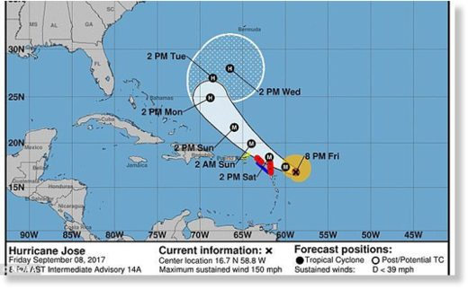
Jose is expected to pass near or east of the northeastern Leeward Islands on Saturday and is currently threatening several islands that were seriously damaged by Hurricane Irma before heading out to sea on Monday

As of Friday morning, a hurricane warning was in effect for the islands of Barbuda and Anguilla, St Martin, and St Barthemy - all islands that were just seriously damaged by Irma.
Barbuda, a tiny Caribbean island of about 1,600 residents, was one of the most severely impacted when the eye of the hurricane passed over it on Wednesday, destroying telecommunication systems and cell towers.
According to Prime Minister Gaston Browne, the storm damaged about 90 percent of the buildings, leaving the nation 'literally a rubble'.
Across the US Virgin Islands, thousands of tourists were trapped, power lines were knocked down and leaves were knocked off trees.
On the island of St Martin, authorities reported looting and gunfire in St. Martin, and a curfew was imposed, reported several news outlets.
Meanwhile, the island of St Thomas saw its harbor in ruins in addition to hundreds of homes and dozens of businesses damaged.
Hurricane Irma weakened from a Category 5 to a still-frightening Category 4 on Friday morning with winds of 155mph as it heads toward Cuba and the Florida coastline.
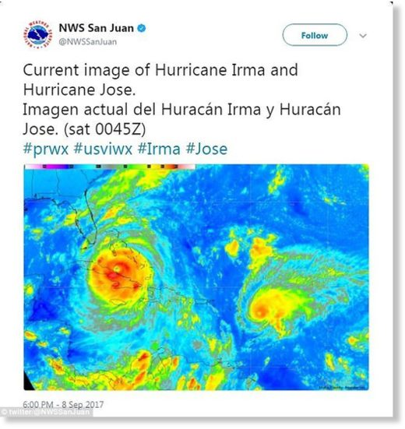
State University meteorologist Philip Klotzbach (Hurricane Irma, left, and Hurricane Jose, right, are spotted in the Atlantic )

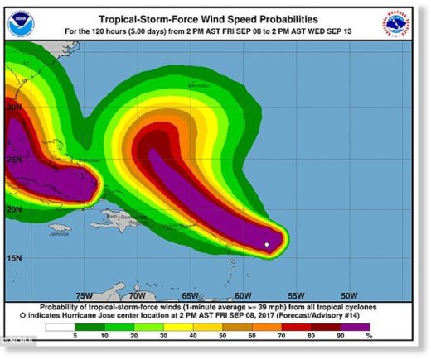
Hurricane Jose (right) could bring up to 10 inches of rain and cause further flooding in parts of the Caribbean as well as hamper relief efforts in the aftermath of Irma

Irma is supposed to weaken but not before causing further chaos and destruction. Meanwhile, Jose could bring up to 10 inches of rain and cause further flooding in parts of the Caribbean.
This is the first time on record that the Atlantic Ocean has had two storms with 150-plus mph winds at the same time, according to Colorado State University meteorologist Philip Klotzbach.
'I don't think it takes a rocket scientist to know that further damage is imminent,' said Inspector Frankie Thomas of the Royal Police Force of Antigua and Barbuda at a news conference.
However, meteorologists say Jose will likely head back out to sea by Monday.
'It's insult added to injury definitely, but nothing compared to what they already went through,' said Jeff Masters of the private forecasting service Weather Underground. 'It's going to hamper relief efforts, so that's a big deal.'

https://www.sott.net/article/361510-Hurricane-Jose-strengthens-to-become-an-extremely-dangerous-Category-4-storm

New Zealand blasted by 2200 lightning strikes in 24 hours
Stuff
Sat, 09 Sep 2017 13:09 UTC
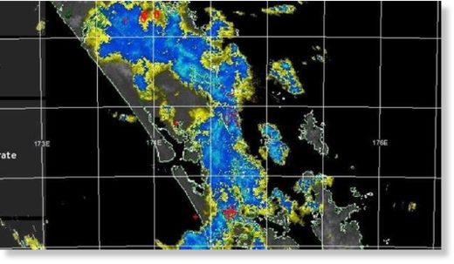
© METSERVICE
The country's been thrashed by lightning as unstable weather takes hold.

New Zealand has been hit by lightning more than 2200 times over 24 hours, with the West Coast of the South Island bearing the brunt of the strikes.
MetService meteorologist Tui McInnes said from 6.15pm on Friday to 7.20pm on Saturday, the country was blasted by 2206 lightning strikes as unstable weather took hold.
Most of those strikes had occurred offshore.
In the 24-hour period, Auckland had been hit nine times, the Bay of Plenty was hit 20 times and Westland was hit 163 times, McInnes said.
Band of heavy rain with thunderstorms heading towards #Auckland - be with you in an hour or so! ^TA pic.twitter.com/1HomFftSoQ
— MetService (@MetService) September 9, 2017
Northland and Waikato were hit 17 and 13 times respectively.
Westland was the hardest-hit place in the country, he said.
"They in particular get a lot of lightning triggered as storm clouds push up against the Southern Alps."
Meanwhile, McInnes said Aucklanders could expect more thunder and lightning on Sunday.
"Some showery stuff that's been passing over Auckland today is set to continue," he said on Saturday evening.
"On Sunday there's a moderate risk of thunder storms throughout the day, with small hail."

https://www.sott.net/article/361524-New-Zealand-blasted-by-2200-lightning-strikes-in-24-hours

Paradise islands devastated by Hurricane Irma (VIDEOS, PHOTOS)
RT
Sat, 09 Sep 2017 18:30 UTC
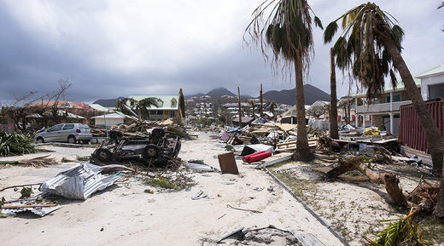
© Lionel Chamoiseau / AFP
Orient Bay on the French Carribean island of Saint-Martin, after the passage of Hurricane Irma.

Images of the devastating impact of Hurricane Irma have filled social media, showing how the deadly storm system has reduced tranquil Caribbean island paradises to ruins.
More than 20 people died as extreme weather barrelled across the Caribbean bringing winds of up to 150mph. Whole neighborhoods have been turned-upside down on islands such as Barbuda, St Barts and the Virgin Islands.
Irma continues to travel west towards Florida, and the US Oceanic and Atmospheric Administration has warned that it will bring "life-threatening wind, storm surge and rainfall hazards".
As islanders struggle to come to terms with the natural disaster, and as MSM coverage continues to focus on Florida, here is the latest on the worst-hit Caribbean regions.
Saint Barthélemy and Saint Martin
Hurricane Irma has claimed the lives of at least nine people on the islands of Saint Barthélemy and Saint Martin.
A state of emergency has been declared on the French territories, with Gérard Collomb, France's minister of the interior, announcing that 1,100 emergency personnel including 380 police officers have been deployed to disaster-hit areas.
Makeshift shelters are reportedly being made in undamaged buildings. The government of the Netherlands has stated that "severe damage" was caused to the Dutch side of Saint Martin.
Barbuda
Structures across almost the entire island of Barbuda were demolished by the sheer force of Irma. It's estimated that up to 95 percent of the island's buildings were flattened during the storm leaving almost all of the 1,600 inhabitants homeless.
The government of Antigua has since stated that except for residents who refused to leave, the "evacuation of Barbuda is complete".
Virgin Islands
Located east of Puerto Rico, the Virgin Island chain has been severely impacted by the power of Hurricane Irma.
Communication and power systems remain down across much of the British Virgin Islands, making it difficult for authorities to assess the total damage. Widespread destruction of homes and buildings has been observed on Tortola and Anegada.

"The destination has lost entire structures and many homes are without roofs, or have been diminished to merely foundations," the BVI government said. "Sadly, there may have been fatalities in the territory, but there are none confirmed at this time as we are still in the assessment process."
In the US Virgin Islands, Governor Kenneth Mapp confirmed that four people died on Saint Thomas Island. He said it was likely that more fatalities would be confirmed.
Turks and Caicos
A collection of 40 islands, the British territory was struck by Irma's hurricane-force winds on Thursday and Friday. There have been no reports of deaths, but images on social media suggest that a number of buildings have sustained damage.
An update posted to a Turks and Caicos Islands Weather Info Facebook page stated that a school roof collapsed during the storm. Residents of Providenciales have also reported power outages.
St Kitts and Nevis
In contrast, the dual island nation St Kitts and Nevis escaped the full force of Hurricane Irma, according to Prime Minister Timothy Harris.
"Our country has been rather blessed and fortunate to have been spared the extreme ravages of Hurricane Irma," Harris said in a statement.
He added that the water supply had been restored to the majority of nation, while the main island roads were passable.
Dominican Republic
Sweeping by the north of the Dominican Republic, Haiti and Cuba on Friday, Hurricane Irma brought floods to the city of Puerto Plata and its surrounding area.
Puerto Rico
Governor Ricardo Rossello has held talks with US President Donald Trump in a bid to ensure emergency funds for the US territory.
According to a statement released on Friday, more than half of the island's population is without power. Three people also died during the storm, including a Camuy resident who was reportedly electrocuted.

https://www.sott.net/article/361571-Paradise-islands-devastated-by-Hurricane-Irma-VIDEOS-PHOTOS

Rare phenomenon caused by Hurricane Irma sucks the water from Bahamas beaches
Kaileen Gaul
Daily Mail (UK)
Sun, 10 Sep 2017 01:42 UTC
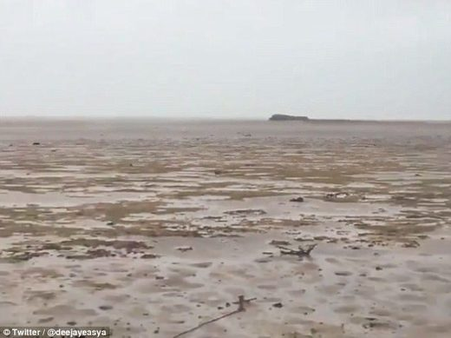
© Twitter@deejayeasya
Before: Hurricane Irma temporarily changed the shape of the ocean after hitting the Bahamas on Friday

Extraordinary footage from the Bahamas show the shoreline receded much farther than normal, exposing what is usually the ocean floor.
Twitter user @Kaydi_K from Long Island, Bahamas wrote on Friday: 'I am in disbelief right now... This is Long Island, Bahamas and the ocean water is missing!!! That's as far as they see #HurricaneIrma.'
The strange video shows her walking on the exposed ocean floor which is dry and covered in large shells. Another Twitter user tweeted a photo of the exposed beach at a different beach in the Bahamas and showed it was back to normal within less than a day.
Hurricane Irma, which hit the Bahamas on Friday, is so powerful that it has altered the shape of the ocean in Long Island, but it will likely be back to normal by Sunday afternoon.
Pressure in a hurricane's center is low and Irma is so strong that it is pulling water into its core, sucking it away from the ocean, according to the Washington Post.
Deputy weather editor and meteorologist Angela Fritz explained that this may be the result of what she calls a hurricane 'bulge'. In the center of the storm, pressure is very low which draws water upward into itself.
She also noted the wind was blowing away from the shoreline on Saturday which is why water has not filled the void yet.
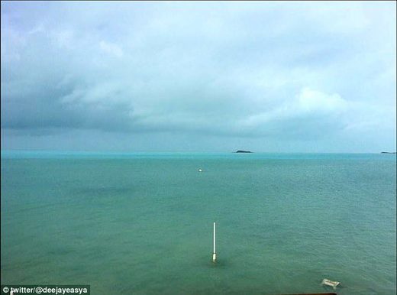
© Twitter@deejayeasya
After: Twitter user @deejayeasya tweeted this photo on Saturday saying the shoreline where he lives in the Bahamas is back to normal 13 hours later

Some Twitter users were concerned since receding shoreline that exposes the ocean floor is often a sign a tsunami is approaching. However, Fritz said the water will not rush back rapidly.
The International Tsunami Information Center notes on its website, when the sea drains away to not investigate because this is a typical sign of an incoming tsunami.
Comment: Last month the Atlantic Ocean dramatically receded off the coasts of Uruguay and Brazil. See also:
Meteotsunami? Ocean dramatically recedes on South American Atlantic coast as huge waves batter the Pacific side

https://www.sott.net/article/361584-Rare-phenomenon-caused-by-Hurricane-Irma-sucks-the-water-from-Bahamas-beaches

Coldest night in 45 years as temperatures plummet in New South Wales
Ally Foster
news.com.au
Mon, 11 Sep 2017 21:35 UTC
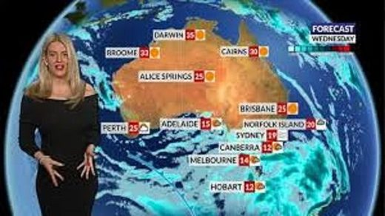

IF you thought winter was over, you might want to think again because spring isn't quite ready to officially take over just yet.
Temperatures across NSW plummeted yesterday with residents in the inland town of Goulburn shivering through the coldest September night in 45 years, with a chilly -5C recorded.
The good news is the cold snap isn't hanging around for too much longer.
Sky News weather meteorologist Tristan Meyer told news.com.au the cold snap was the result of a high pressure system.
"This high pressure system will also lead to predominantly sunny skies and a warm day over the southeast," he said.
The cool overnight temperatures was a significant drop for Goulburn with the average minimum for this time of year being 4.6C.
There's also good news for Tasmanians though who were bombarded with snow last week.
It looks like the icy conditions have eased off and are being replaced with more springlike temperatures.
However there are still some strong wind warnings in place for the South West Coast and Central West Coast of Tasmania for the beginning of the week.
Temperatures dropped to -6C in parts of the state during the cold snap but the freezing weather eventually subsided with Hobart reaching a maximum on 15C today.
While southeastern Australia is shivering, it's a different case entirely for the northern part of Australia.
The Bureau of Meteorology has issued a fire weather warning for Darwin and Adelaide River as that high pressure system slowly moves eastwards causing hot and dry winds to sweep across parts of the Northern Territory.
Here is what the weather is looking like around the rest of Australia.
NSW/ACT
Sydney is going to get some warmer weather, with a maximum of 24C tomorrow and 29C on Tuesday.
SOUTH AUSTRALIA
Adelaide will see maximum temperatures of 23C tomorrow and 20C on Tuesday, with a chance of showers throughout the week.
WESTERN AUSTRALIA
Perth is set to see a few clearing showers as the week begins, with maximum temperatures of 20C tomorrow and Tuesday.
VICTORIA
Melbourne is going to have patchy rain too, with temperatures tomorrow reaching 19C and dropping to 17C on Tuesday.
QUEENSLAND
Brisbane is in for a sunny week with maximum temperatures of 27C tomorrow and 30C on Tuesday.

https://www.sott.net/article/361733-Coldest-night-in-45-years-as-temperatures-plummet-in-New-South-Wales

Hurricane Irma: Florida declares State of Emergency as storm upgraded to Category 5 - UPDATES
RT
Mon, 04 Sep 2017 19:28 UTC
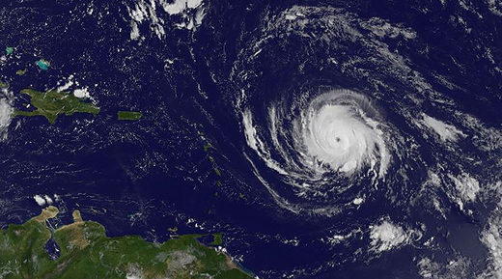
© HO / NASA / GOES PROJECT / AFP
This image obtained from the NASA's GOES Project shows Hurricane Irma on September 4, 2017

Florida Governor Rick Scott has declared a state of emergency for the entire state in response to Hurricane Irma. A number of idyllic Caribbean islands have been warned that they are in the direct path of the Category 4 storm.
Governor Scott issued an executive order Monday stating that "Hurricane Irma is a major and life-threatening storm and Florida must be prepared."
Scott said he wanted to ensure that local governments have ample time and resources to prepare for the storm.
The latest advisory indicated the threat to South Florida was increasing and residents should be prepared.
The extreme weather conditions are now expected to barrel past the British Virgin Islands, Puerto Rico, Saint Martin, Antigua, Montserrat and St Kitts within the next 36 hours, the US National Hurricane Center reports.
Hurricane Irma has also been upgraded to a Category 4 storm in the last number of hours. It is currently surging west over the Atlantic Ocean at 14mph.
Earlier, the meteorological office of Antigua and Barbuda warned the storm was carrying winds of up to 115mph and that "further strengthening is possible" before it passes through the Caribbean.

Dangerous increases in water levels by up to 9 feet could be experienced along coastal regions of the Leeward Islands, which are made up of picturesque isles such as St Lucia, Martinique and Guadeloupe.
US weather experts believe the hurricane is most likely to hit the northern part of the island group.
"The deepest water will occur along the immediate coast in areas of onshore winds, where the surge will be accompanied by large and destructive waves," the NHC said.
"Hurricane conditions are possible within the hurricane watch area in the Virgin Islands and Puerto Rico by late Wednesday, with tropical storm conditions possible by early Wednesday," it added.
Residents and boats owners on the islands have been urged by the British Virgin Islands government to secure their property in advance of Hurricane Irma.
Comment: See also:
- Hurricane Irma chugs west
- Powerful Hurricane Irma could be next weather disaster - UPDATE
Update (Sept. 5)
The US National Hurricane Center has announced that Irma has been upgraded to a Category 5 hurricane with wind speeds that could reach 175 mph (280 km/h). The hurricane is expected to reach the US and British Virgin Islands, along with Puerto Rico, Wednesday.
Update (Sept. 7)
More Irma coverage from the past 2 days:
- Florida shutting down its 2 nuclear plants before arrival of Hurricane Irma
- Category 5 Irma hits Leeward Islands at peak strength, eye misses Puerto Rico, Virgin Islands
- Hurricane Irma pummels the Dominican Republic
- SpaceX deploys covert US military spaceplane as Hurricane Irma closes in
- Virgin Islands issues emergency order allowing seizure of private weapons ahead of Hurricane IrmaUPDATE: Order to 'Seize arms' does not mean 'Seize arms'
- Brave but foolhardy: Delta Airlines pilot pulls off dramatic NY-Puerto Rico roundtrip ahead of Hurricane Irma landfall
- Miami-Dade holds off on Irma evacuation orders - for now; UPDATE: Evacuation orders given for some areas
- Two Florida nuclear power plants are directly in the path of Hurricane Irma
- Category 5 Hurricane Irma stronger than all of 2017's other eight Atlantic storms combined
- Tropical triple threat: Hurricanes Katia & Jose follow on the heels of Irma
- 'Barbuda is literally rubble': Shocked PM says Hurricane Irma destroyed 90% of homes on tiny Caribbean island
- Rain from monster Hurricane Irma starts hitting Puerto Rico
- Saint Martin is slammed by 185mph winds of Hurricane Irma
- Irma is now the strongest hurricane ever recorded outside of the Gulf and Carribean
- Hurricane Irma takes out electricity, damages rooftops in Caribbean
- Category 5 Irma becomes most powerful hurricane ever recorded in Atlantic Ocean
- 'Potentially catastrophic' Hurricane Irma will likely impact Florida
- Hurricane expert Maue: Extrapolating scale, Hurricane Irma could be a "Category 6"
- Hurricane Irma intensifies, now Category 4 storm threatening Cuba and Florida
The mayor of Miami beach warned residents yesterday to get out ASAP, saying, "I'll do anything in my power to convince them this is a very serious storm. This is a nuclear hurricane. They should leave the beach, they must leave the beach," he said. Monroe County officials are warning all residents of the Keys to get out while they can.
Bryan Norcross, senior hurricane specialist at The Weather Channel, said Irma potentially threatens every major Floridian city:
"When a storm is threatening like this, my day is pretty much 7 a.m. to 11 p.m., or maybe a little after. I start in the morning, where we have morning meteorology meetings, and I post extensively on Facebook. I stay up through the 11 o'clock advisory at night," he said.
Norcross said his Facebook posts reached 4.5 million people during the past week - including 900,000 on Wednesday morning - as Irma continued to gain strength.
"The west coast of Florida - including the Ft. Myers/Cape Coral/Naples area and Tampa Bay - are spectacularly vulnerable to storm surge. Much more so than the east coast, which still has many threatened areas," Norcross wrote during a lengthy Facebook post Wednesday morning. "If the storm looks like it could go up the west coast, evacuations are going to be required there, which will create an epic movement of people through the State of Florida.
"If this happens, and you are in an evacuated area, do not dawdle. Do not even think about dawdling. Immediate action will be required," Norcross wrote.
Whether or not this disaster scenario occurs all depends on "the turn":
Irma has maintained 180+ mile per hour winds for more than 24 hours. The last storm to maintain long-lasting category 5 strength was Hurricane Allen, which only maintained 180+ mile per hour winds for 18 hours. Hurricane Irma is expected to maintain Category 5 strength through Friday before weakening to a category 4 storm on Saturday as it approaches Cuba and the Bahamas.
Once Irma reaches the Bahamas, our focus will shift to Irma's turn. All models have Irma making a turn to the north sometime between Friday and Sunday.
...
"You see many of the models showing this turn. This turn is going to be everything," says CBS Miami Meteorologist Craig Setzer. "The problem is, we don't know exactly when or where this turn is going to occur. An earlier turn takes to the east, a later turn takes it to the west of us, and a turn that's probably Saturday morning to Saturday night in that time frame could potentially take it to us, so we're going to be watching that very, very closely."
If Irma turns to the north before it reaches the 80 degree latitude line, the center of the storm would likely stay offshore, farther to the east. If it turns on or near the 80 degree latitude line, the track of Irma would likely be more devastating to South Florida. If Irma turns west of the line, Miami-Dade and Broward Counties would likely fare better.
While mindful of the dangers, billionaire Richard Branson refused to leave his home in the Virgin Islands, vowing to stay alongside "our team" and weather the storm. A pro teen surfer has died while trying to catch one of Irma's waves off Barbados. The four most solid buildings on Saint Martin island have been flattened, meaning it's likely that practically all structures on the island have been destroyed or seriously damaged.
Weather Channel founder John Coleman had this to say on Facebook: "Take a trip west and live. It you stay put your ssn on your arm with a sharpie."
Update (Sept. 8)
After 11 dead, dozens injured, and thousands of homes destroyed on Caribbean islands, the French, British and Dutch governments have already rushed to aid the isles. At least 14 more have died on Turks and Caicos Islands. Irma has been downgraded to Category 4, but is predicted to hit Florida on Sunday. Miami is prepping for Irma's onslaught, and forecasters think it could travel up Florida and into Georgia and South Carolina. 5.6 million people have been ordered to evacuate Florida. Shelters are already overflowing after a chaotic start to the evacuation. The USS Abraham Lincoln and other battleships are getting into position to provide humanitarian relief and support if needed.
Meanwhile, 59k Americans are engaging in a somewhat ridiculous viral game to blow Irma away using house fans. 1.2 million people have been affected so far, but that could increase to 26 million. This reaction seems apt (sans the bit about global warming):
"Nature's gone crazy," mused Jeff Masters, meteorology director at the private service Weather Underground. "Welcome to the future. Extreme weather like this is going to be occurring simultaneously more often because of global warming."
View the latest predicted tracks here. Another below:
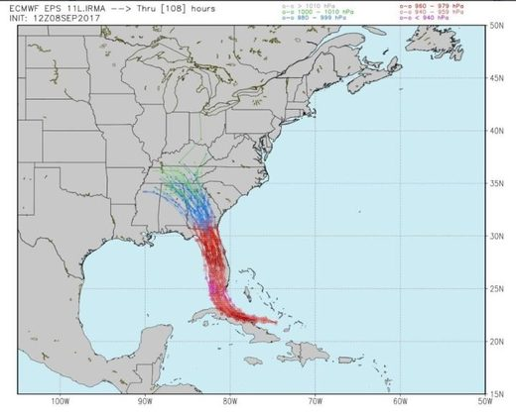

As for Irma being the worst hurricane ever, not quite. Irma tied 2nd place for windspeed, putting it in the top five; tied 12th for atmospheric pressure. And no, global warming isn't increasing the frequency of hurricanes. There has been no statistically significant increase over the past 150 years or so. Neither has there been an increase in the percentage of tropical storms turning into hurricanes.
Update (Sept. 9)
The National Hurricane Center has updated Hurricane Irma to a maximum level of Category 5. It is lashing Cuba with strong winds and heavy rain after devastating several Caribbean islands. This is the first time a category five hurricane has hit Cuba in decades. But the Bahamas have largely been spared after Irma changed track.
Meteorologists expect Irma to make landfall in the Florida Keys between 5am and 7am ET on Sunday. South Florida is under a state of emergency as residents evacuate or prepare to take cover. Maximum sustained winds are at 160 mph, but there will be stronger gusts of winds as well. The storm's wind speeds will increase after Irma passes Cuba and comes forth into the extremely warm waters close to the Florida Keys, forecasters at the National Hurricane Center said.
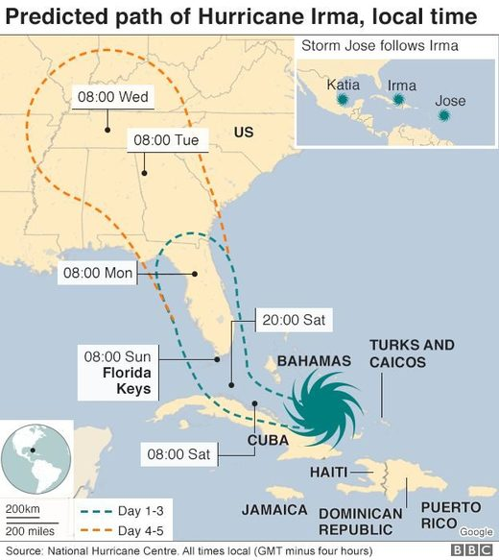
© National Hurricane Centre

5.6 million people, or 25% of the state's population, have been told to leave Florida as the storm approaches. Hurricane warnings have been extended northward along the Florida Peninsula. At least 20 people are known to have died so far across the Caribbean.
EPA personnel are working to secure some of the nation's most contaminated toxic waste sites ahead of the hurricane. Florida has 54 Superfund sites, six of which are near Miami in low-lying, flood-prone areas. A 2012 risk analysis concluded that flooding at such sites pose risks of spreading contaminated soil and groundwater and could contaminate personal wells.
Meanwhile Hurricane Jose has moved closer to category five strength, with tops winds of 155 mph (250kmh) as it heads towards the eastern Caribbean islands ravaged by Hurricane Irma. In the Gulf of Mexico, Hurricane Katia was making landfall north of Tecolutla, Mexico early today and is still rated a category one hurricane with winds of 75 mph (120kmh). Forecasters expected the hurricane to weaken quickly over the next 24 hours.
Hurricane Irma has reduced the tranquil Caribbean island paradises to ruins:
More than 20 people died as extreme weather barrelled across the Caribbean bringing winds of up to 150mph. Whole neighborhoods have been turned-upside down on islands such as Barbuda, St Barts and the Virgin Islands.
...
Makeshift shelters are reportedly being made in undamaged buildings. The government of the Netherlands has stated that "severe damage" was caused to the Dutch side of Saint Martin.
In Barbuda up to 95% of the island's buildings were flattened, leaving almost all of the 1,600 inhabitants homeless.
Communication and power systems remain down in much of the British Virgin Islands.
St Kitts and Nevis escaped the full force of the storm while the Dominican Republic, Haiti and Cuba experienced flooding.
The Governor of Puerto Rico has had talks with President Trump to ensure emergency funding. More than half of the island's population is without power and three people died during the storm. One resident of Camuy was reportedly eletrocuted.
Update (Sept. 10) 09.00 CET
The first hurricane-force wind gust had been recorded in the Florida Keys, a low-lying island chain off the state's southern coast, said the US National Weather Service. Florida faces the "most catastrophic" storm in its history as Hurricane Irma prepares to unleash devastating force on the state, including 120mph winds, life-threatening sea surges that could submerge buildings and an advance battery of tornadoes.
In Florida's south-west, officials expected sea surges as high as 15ft (4.5 metres), which can rapidly rise and fall. "Fifteen feet is devastating and will cover your house," Governor Rick Scott said. "Do not think the storm is over when the wind slows down. The storm surge will rush in and it could kill you."
Its most recent victim, Cuba, experienced 125mph (200kmh) winds on Saturday that damaged hotels and forced evacuations as far along the coast as low-lying areas of the capital Havana. The storm had been downgraded to Category 3 after making landfall as a rare Category 5 hurricane in Cuba early Saturday morning.
It has now been downgraded to Category 4 after gathering intensity over the warm waters of the Florida Straits, according to the National Hurricane Center and is 70 miles from Key West and has sustained winds of 130mph (210kmh).
Update (Sept. 10) 19.30 CET
A dire warning from the National Weather Service about the south-west coast of Florida. The service has also announced an extreme wind warning for Collier County: its radar detected winds stronger than 115mph, "associated with the eyewall" of the storm, are approaching the coast 10 miles south of Everglades City. Nearby are Naples, Marco Island, Chokoloskee, and Golden Gate Estates.
In downtown Miami, waters are quickly rising in tandem with the gusting winds.
Governor Nathan Deal has expanded the state of emergency to take in the entire state of Georgia. "The state of emergency now includes all 159 counties in Georgia. State government will be closed Monday and Tuesday for all employees except essential personnel."
The Mayor of Tampa has said he and his fellow city residents "are about to get our own version of what hell looks like." Irma is expected to weaken to a category three hurricane as it moves northwards, making tonight the first time in decades that Tampa will have been struck by such a forceful storm.
Cubans are dealing with the aftermath of deadly Hurricane Irma, the most powerful storm to hit the country since 1932.
The eastern and northern coasts were the worst hit, the force of the storm sent flooding further inland and for a period on Saturday, Irma covered most of the island.
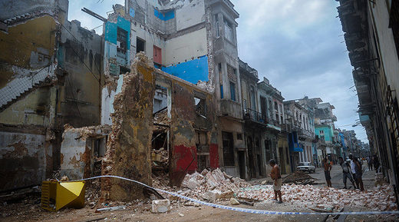
© Yamil Lage /Agence France-Presse
Cubans stand bt a collapsed building in Havana, on September 9, 2017.

ACN noted that the Civil Defense put the provinces of Mayabeque and Artemisa and the capital Havana in an "alarm phase" at 8am on Saturday.
Authorities shut off power in large parts of Havana and evacuated around 10,000 residents, even though the storm was expected to miss the city by around 240km. Regardless of this distance, two blocks along Havana's famous sea front were flooded after the sea surged into the streets.
Irma sets new records
As of September 9
Intensity Measures
- 185 mph lifetime max winds - tied with Florida Keys (1935), Gilbert (1988) and Wilma (2005) for second strongest max winds of all time in Atlantic hurricane. Allen had max winds of 190 mph in 1980
- 185 mph lifetime max winds - the strongest storm to exist in the Atlantic Ocean outside of the Caribbean and Gulf of Mexico on record
- 185 mph max winds for 37 hours - the longest any cyclone around the globe has maintained that intensity on record. The previous record was Haiyan in the NW Pacific at 24 hours
- 914 mb lifetime minimum central pressure - lowest since Dean (2007) and 10th lowest in satellite era (since 1966)
- 914 mb lifetime minimum central pressure - lowest pressure by an Atlantic hurricane outside of the western Caribbean and Gulf of Mexico on record First Category 5 hurricane in the Atlantic since Matthew (2016) and first Category 5 hurricane in the tropical Atlantic (7.5-20°N, 60-20°W) since Hugo (1989)
- 3.25 day lifetime as a Category 5 hurricane - tied with Cuba (1932) for longest lifetime as Category 5
- 3 consecutive days as a Category 5 hurricane - the longest in the satellite era (since 1966)
- 7.25 major hurricane days - tied for 6th most in the satellite era (since 1966) 3.75 major hurricane days in the tropical Atlantic (7.5-20°N, 60-20°W) - trailing only Luis (1995) for major hurricane days in the tropical Atlantic
Integrated Measures
- Generated the most Accumulated Cyclone Energy by a tropical cyclone on record in the tropical Atlantic (7.5-20°N, 60-20°W) Generated more Accumulated Cyclone Energy than the first eight named storms of the Atlantic hurricane season (Arlene-Harvey) combined Generated the most Accumulated Cyclone Energy in a 24-hour period on record, breaking old record set by Allen (1980)
- 59.5 Accumulated Cyclone Energy units so far - the 3rd most by an Atlantic hurricane in the satellite era (since 1966) - trailing only Isabel (63.3) and Ivan (70.4)
- Generated more Accumulated Cyclone Energy than 15 entire Atlantic hurricane Landfall Records
- Leeward Islands: Strongest storm on record to impact the Leeward Islands defined as 15-19°N, 65-60°W for this calculation, with max winds of 185 mph.Okeechobee Hurricane (1928) and David (1979) were previous strongest at 160 mph
- Turks and Caicos: Closest approach of a Category 5 hurricane on record - The Bahamas: First Category 5 hurricane to make landfall since Andrew (1992)
- Cuba: First Category 5 hurricane to make landfall since the Cuba Hurricane of 1924
Stormchasers, Simon Brewer and Juston Drake, risk their lives to get footage of the Hurricane. This footage was taken at Saddlebunch Keys in Monroe County:
Miami's "Wall Street of the South" looks like an ocean with roadways flooding with rivers of water.
Some Floridians got it into their heads that they can scare off the Hurricane by shooting at it and sponsored a Facebook event, 'Shoot at Hurricane Irma'. The Pasco County Sheriff's office was forced to issue a warning.
The event's popularity sparked a series of similar events, including 'Flame Throwing Hurricane Irma' and 'Sing "All Star" by Smashmouth So Loud the Soundwaves Turn Irma Away'.
In a worst case scenario, the damage forecast estimates for Tampa, Florida include a half a million homes and hundreds of casualties. A 2015 study conducted by Boston firm Karen Clark & Co stated that the damage could total $175 billion for the Tampa area alone. Meanwhile, hurricane grade winds have hit the Florida Keys:
Bahamians freaked out at as the outgoing hurricane sucked the water from Long Island Bay.
The ominous-looking occurrence was in fact caused by a combination of low tide, low pressure and strong winds in the right direction, which literally pushed the water away from the long narrow bay. The phenomenon has been dubbed "reverse storm surge" by some of those explaining it online.
Update (Sept. 11) 08.00 CET
The National Hurricane Center (NHC) has downgraded Irma to category 1 and is "weakening" as it heads north of Tampa. Four hundred miles wide, Irma initially moved at 8mph, slower than forecast, and lost strength as it raked the peninsula. Irma made landfall on Marco Island as a category 3 storm, after hours of blasting south Florida with stinging, near horizontal rain, and sudden tornadoes.
The most immediate threat from the storm is the possibility of storm surges. The critical point could come at high tide, the USNHC said, and bring up to 15ft (4.5m) of water flooding inland in the Tampa area. With concerns that Florida toxic materials could leak scores of Environmental Protection Agency staff have been working to secure equipment and isolate hazardous materials at Florida's 54 Superfund sites in the hours before Hurricane Irma made landfall - two weeks after similar sites were damaged by Hurricane Harvey.
Superfund sites are heavily contaminated former industrial zones. However, the EPA "can't guarantee it 100 percent," that there will not be contamination following the storm, Senator Marco Rubio told AP.
More than 3.4 million homes in the state are without power, and parts of the city of Miami are under water. Drone footage captured the severe damage and flooding in Naples.
Yesterday President Donald Trump approved a major disaster declaration for Hurricane Irma in Florida which authorizes 100 percent federal reimbursement for 30 days in all counties for emergency protective measures, such as the costs of running emergency operation centers, hurricane shelters and related expenses.
Update (Sept. 11)
Some cities were caught of guard by Irma over the weekend due to an unexpected shift in the hurricane's path. Naples, for example, didn't have time to evacuate once forecasters warned it was headed their way. The turn put Tampa in Irma's path - Tampa hasn't been hit by a hurricane since 1921. The Irma survivors in the Caribbean braced yesterday for Jose and armed looters. Even as Irma moved away from Cuba over the weekend, 6-meter waves surged on Havana coast, flooding homes and streets up to 600 meters into the city. Thankfully, as of yesterday there were no reported deaths. 5000 tourists had to be evacuated from the coast.
The NYT has a harrowing account of those who survived Irma on St. Martin:
"All the food is gone now," Jacques Charbonnier, a 63-year-old resident of St. Martin, said in an interview on Sunday. "People are fighting in the streets for what is left."
In the few, long days since Irma pummeled the northeast Caribbean, killing more than two dozen people and leveling 90 percent of the buildings on some islands, the social fabric has begun to fray in some of the hardest-hit communities.
Residents of St. Martin, and elsewhere in the region, spoke about a general disintegration of law and order as survivors struggled in the face of severe food and water shortages, and the absence of electricity and phone service.
The Miami Herald summarizes this morning's Irma developments:
Hurricane Irma left a trail of damage across South Florida: flooded streets, downed trees, crushed cars, collapsed cranes, leaky homes. The long slog of assessing the damage across the region began Monday. Miami-Dade and Broward counties were spared the worst of the storm, but the Florida Keys were hit hard. Ten people were declared dead in Cuba. Now, Jacksonville is flooding.
Florida was hit from coast to coast with winds up to 130 mph, before downgrading to Cat. 2 (with speeds of approximately 100 mph). Water surged into Miami's streets at least 3 blocks from shore. Pinellas County sealed off all access until damage can be assessed: "Sheriff's deputies warned citizens to stay off all county roads because of hazardous conditions, including traffic light outages, downed powerlines and significant debris blocking roadways." The Everglades were lashed by Irma: extreme wind gusts, impassable roads, 4- to 5-foot flooding due to the surge.
"(The storm) would come as a hammer and just snap a tree as if it were a twig," he said. "It was like buckets of water on the corner of the house," said his partner, Marlene Sassaman.
Similar damage in Tampa Bay: downed trees and power lines block roads. By then, Irma had weakened to Category 1 (85 mph). Forecasters expect Irma's center to stay inland over Florida and then move into Georgia, Alabama and Tennessee.
6 million Floridians are now without power
Florida's largest utility reported that the storm had knocked out power to nearly three-quarters of its customers. More than 6.5 million residents across the state woke up Monday to no electricity.
NHC officials said the storm's center was moving toward Florida's northwestern coast and could cross the eastern Florida Panhandle into southern Georgia Monday afternoon, moving into southwestern Georgia and eastern Alabama by Monday night and Tuesday morning.
1.5 million in Georgia are without power, two deaths
Nearly 1.5 million Georgians were without power on Monday as Irma continued its slow march through the state.
Two deaths in the state have been blamed on the tropical storm so far. One was a 55-year-old man killed after a tree smashed through his home in Sandy Springs. He was sleeping at the time. A South Georgia man died after heavy winds swept him off his roof Monday morning in Worth County. Neither has been publicly identified.
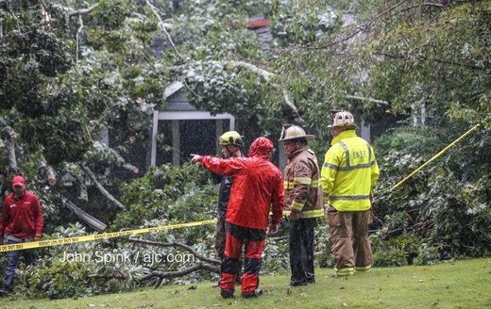
© John Spink/The Atlanta Journal-Constitution
A 55-year-old Sandy Springs man was killed when a tree crashed into his home.

https://www.sott.net/article/361122-Hurricane-Irma-Florida-declares-State-of-Emergency-as-storm-upgraded-to-Category-5-UPDATES

Power surge: 800 lightning bolts strike San Francisco in one day
RT
Tue, 12 Sep 2017 11:25 UTC
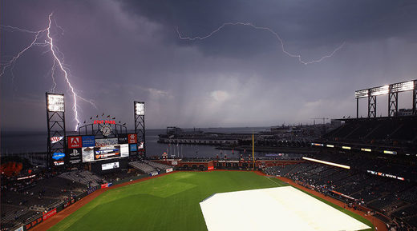
© Ezra Shaw / Getty Images / AFP

After a spell of intense heat in the Bay Area, a huge storm finally broke over San Francisco on Monday, unleashing more than 800 lightning strikes in mere hours, according to the National Weather Service.
Starting around midday, the lightning blitz continued after night fell, treating locals to a spectacular light show.
The incessant storm forced the baseball game between the San Francisco Giants and their California rivals, the Los Angeles Dodgers, to be delayed, as bolts of lightning rained down around the stadium.
According to local news station KRON 4 a worker at San Francisco Airport was struck during the barrage of lightning strikes.
The worker was operating an aircraft towing vehicle when he was struck. Luckily he did not sustain serious injuries and wasn't even taken to hospital.

https://www.sott.net/article/361747-Power-surge-800-lightning-bolts-strike-San-Francisco-in-one-day

Nearly 40,000 lightning strikes in 24 hours lit up the sky in southwest California
Veronica Rocha
Los Angeles Times
Mon, 11 Sep 2017 12:48 UTC
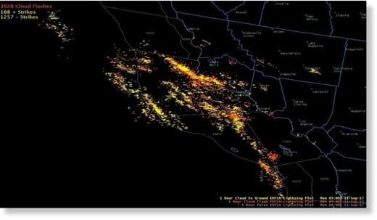
© National Weather Service
A volatile storm brewing over Southern California produced nearly 40,000 lightning strikes and threatened to bring more rain Monday, forecasters said

A volatile storm brewing over Southern California produced nearly 40,000 lightning strikes and threatened to bring more rain and thunderstorms Monday, forecasters said.
The lightning and in-cloud flashes were observed in the last 24 hours over Los Angeles, Santa Barbara, San Luis Obispo and Ventura counties, with the most activity occurring Sunday evening, according to the National Weather Service. In one instance, forecasters recorded more than 5,000 lightning bolts in the area over a three-hour period.
"That's a lot," said meteorologist Kathy Hoxsie of the weather service in Oxnard.
Although the storm brought plenty of lightning, rain totals were less than half an inch in Santa Barbara County on Sunday. The greatest rain total was observed at Sudden Peak, which received .44 inches.
In Los Angeles County, Lake Palmdale received .02 inch of rain.
Forecasters said a low-pressure system lingering off the Southern California coast was pulling moisture from the southeast and dumping rain over the area.
By Monday morning, heavy showers, thunderstorms and 35-mph winds were reported in eastern Los Angeles County.
"We're still not quite out of the woods yet as models show another increase in instability this afternoon, especially across interior [San Luis Obispo] County," the weather service said in a statement.
The showers should move out of the Southern California by Tuesday and will be replaced with a deep marine layer for the rest of the week.

https://www.sott.net/article/361754-Nearly-40000-lightning-strikes-in-24-hours-lit-up-the-sky-in-southwest-California

Hundreds left without power, at least 8 dead after storm dumps twice the monthly rainfall on northern Italian city of Livorno
RT
Tue, 12 Sep 2017 07:45 UTC
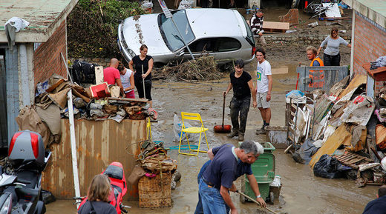
© Leonardo Bianchi / Reuters
People are seen cleaning mud following floods in Livorno, Italy, September 10, 2017

Eight people have died and hundreds of homes left without power after a storm dumped double the monthly rainfall on the northern Italian city of Livorno, according to local media.
The Mayor of the Tuscan city, Fillipo Nogarin, tweeted that around 290 homes were still without power Monday, down from 2700 the day before.
Tuscany President Enrico Rossi said a state of emergency would be declared in the area tomorrow, with an initial €3 million being put into the recovery budget, according to La Repubblica.
Freelance journalist Alessandro Barabino posted pictures of the damage to the Three Bridges area of the city.

The local government had issued an 'orange alert' ahead of the storm, but after 40 centimeters (1.3ft) of rain fell in just four hours over the weekend, questions are being asked why the alert had not been upgraded to 'red.'
Nogarin shrugged off the criticism, writing on Twitter: "Let's get some clarity and stop these controversies that don't help anyone."
Four members of the same family were killed after their basement flat flooded during an intense period of rainfall, transforming the streets and surrounding areas into rivers and lakes. A four-year-old boy was among the victims.
The grandfather of the family is reported to have saved a three-year-old family member before being overcome by the floodwaters.
The latest victim, Martina Bechini, was found by police along the river D'Ardenza after her home was engulfed by water in Via Garzelli, southeast of the city. The body of her husband, Filppo Meschini, had been found earlier, two kilometers away their home, according to Livorno local il Tirreno.
Nogarin also announced a period of mourning during which flags will be flown at half-mast over municipal buildings until the funerals of the victims have taken place.
Rome was also badly affected by flooding after the storm moved southwards Sunday, with the Italian capital sustaining as much as 10 centimeters of rain in just three hours.
Heavy flooding sparked traffic chaos and flights disruptions as well as landslides in the surrounding areas. Rubbish skips were also reportedly seen floating past the Roman Colosseum, one of the city's most famous historical landmarks.
Critics claimed the effects of the storm were exacerbated by the lack of clear storm drains across the city.
The weather alert for the city remains on orange for the next 24-36 hours as city council chiefs hold emergency meetings to discuss the state of the River Tiber.
Italy had been suffering from sweltering hot conditions this summer, with droughts reported in areas all across the country. Conditions had been considered so severe that the city of Rome was forced to shut off its famous public water fountains.

https://www.sott.net/article/361757-Hundreds-left-without-power-at-least-8-dead-after-storm-dumps-twice-the-monthly-rainfall-on-northern-Italian-city-of-Livorno

Flooding in Zadar, Croatia after 280mm (11 inches) of rain in 24 hours
Richard Davies
Floodlist
Tue, 12 Sep 2017 18:15 UTC
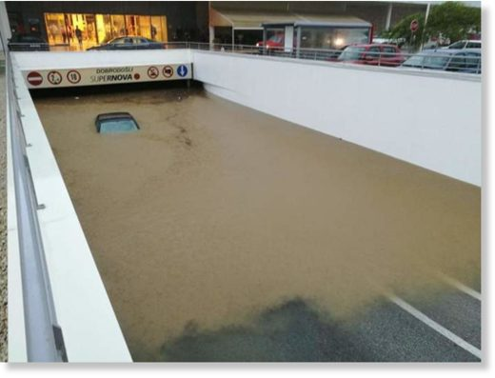

Torrential rainfall of almost 280 mm in 24 hours fell in Zadar, Croatia, causing damaging floods in the city.
Many roads schools and hospitals in Zadar were closed as a result. Local media report that a bridge was completely destroyed by raging flood water.
Local emergency services received over 1,000 calls for assistance. Since yesterday authorities and emergency services have helped drain 127 flooded buildings.
Local media say that 242 mm fell in just 4 hours. According to Croatian Meteorological and Hydrological Service (Državni hidrometeorološki zavod - DHMZ), 279.6 mm fell in 24 hours to 12 September. DHMZ says the average rainfall for the month of September in Zadar is 105 mm.

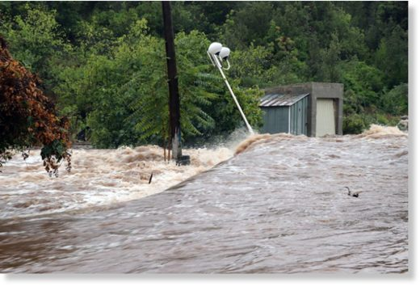

Other areas in the Balkans also recorded heavy rain between 11 and 12 September. Tirana in Albania recorded 72 mm in 24 hours and Mostar, Bosnia Herzegovina recorded 50 mm.
The recent rain comes just 2 days after deadly floods stuck in Italy after 250 mm of rain fell in just 2 hours in the city of Livorno, Tuscany. At least 6 people died in the floods.
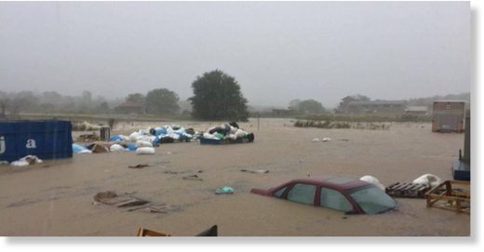

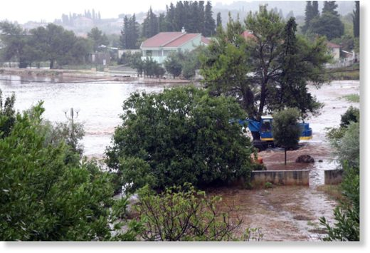

https://www.sott.net/article/361807-Flooding-in-Zadar-Croatia-after-280mm-11-inches-of-rain-in-24-hours

China faces double danger from typhoons as Talim and Doksuri threaten to strike coastline
Stephen Chen
South China Morning Post
Wed, 13 Sep 2017 05:01 UTC
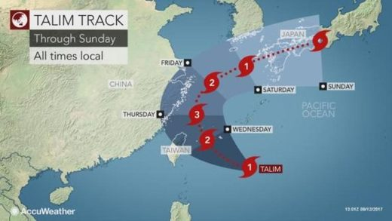
© AccuWeather

Authorities warn 10 provinces could be hit by powerful storms as Taiwan braces for first impact
Ten provinces in China's wealthiest coastal regions could be hit by two powerful typhoons within 24 hours, the government has warned.
But they could also miss China altogether with a "last-minute" turn and hit other countries, according to the latest estimates.
Typhoon Talim was less than 500 kilometres southeast of Zhejiang province at about 10am. It could make a landfall in Zhejiang soon after reaching its peak on Thursday evening or Friday morning, according to a forecast by an expert panel led by Chen Lei, Minister of Water Resources and deputy chief of the national anti-flooding command office.
The authorities in Taiwan issued a maritime warning and airlines cancelled some flights on Wednesday as the island braced for Talim, which was expected to hit northern cities, including Taipei, and had the potential to become a super typhoon.
Meanwhile, Doksuri recently formed to the west of the Philippines and was heading to Hainan province and expected to make a landfall at about the same time as Talim.
"The areas to be affected by Talim are the most economically developed regions in our nation's eastern coastline with large cities, high population density, tall buildings and plenty of industrial infrastructure," said a statement of the expert panel released by Xinhua.
Talim was expected to gain in strength as it swept towards Taipei and other cities on Taiwan, lashing them with strong wind and heavy rain, the island's Central Weather Bureau said.
Its greatest impact would be felt later on Wednesday and on Thursday, the bureau said on its website, when it was expected to slam into the north and northeast with maximum sustained wind speeds of 137 kilometres per hour (85 mph) and gusts of up to 173 kilometres an hour.
It had not yet been determined whether the Taiwan government would close financial markets, companies or schools on Thursday. An announcement would be made later on Wednesday if closures were considered necessary.
China Airlines and EVA Airways, Taiwan's two largest carriers, said they would cancel some inbound and outbound international flights scheduled for later on Wednesday. A warning for sea traffic was also issued by the Central Weather Bureau.
Formosa Petrochemical Corporation, Taiwan's second-biggest oil supplier, said it had prepared to close its supply port if necessary as Talim approached, although it was waiting for a government directive.
China's National Meteorological Centre warned on Tuesday that Talim could intensify and turn into a super typhoon as it churned towards Taiwan and Zhejiang and Fujian provinces on the mainland.
As many as half a million people may need to be evacuated if the storm intensifies.
Coastal areas in southern China such as Guangdong province have taken repeated hits this year and they face the severe threat of flooding with the arrival of Doksuri, according to the expert panel.
The central government had dispatched 11 emergency response team to provinces and large cities including Fujian, Shanghai, Jiangsu, Anhui, Jiangxi and Guangxi, according to Xinhua.
Waves as high as seven or six metres are expected to hit Zhejiang and Guangdong.
But the authorities said the two systems were affecting each other, creating uncertainty about their future paths.
Talim could yet make a U-turn towards southern Japan, and Doksuri may be diverted towards Vietnam instead.

https://www.sott.net/article/361848-China-faces-double-danger-from-typhoons-as-Talim-and-Doksuri-threaten-to-strike-coastline

Tropical Storm Maring floods metro Manila, Philippines
GMA News Online
Wed, 13 Sep 2017 12:07 UTC
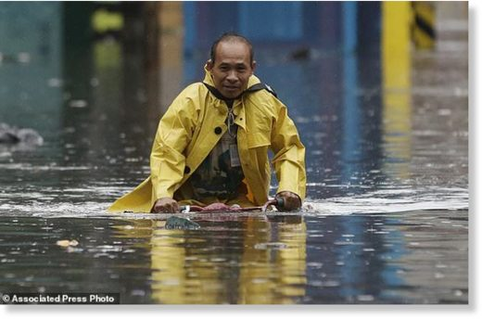
A man pedals his bicycle along a flooded street in Manila, Philippines on Tuesday, Sept. 12, 2017.

The torrential rains brought by Tropical Depression Maring flooded several parts of the National Capital Region on Tuesday, leaving roads impassable and commuters stranded.
The floods congested at least four major intersections in Malabon City alone, GMA 7 news program "24 Oras" reported on Tuesday.
Among them flooded intersections were Governor Pascual Avenue corner Maria Clara Streets, Maya Maya corner Pampano Street, and the intersection of Tonsuya and Sitio 6 in Katmon.
Rain poured heavily in Malabon around 2 p.m., and a waist-high flood rose within the next hour, particularly along Samson Road.
With PUV's unable to ply their routes, commuters had no choice but to wade through the flooding.

Meanwhile, at least seven families in Valenzuela City were forced to spend the day at an evacuation center at the Valenzuela National High School, according to Russel Fausto of the Valenzuela City Disaster Risk Reduction And Management Office (VCDRRMO).
However, some locals who had grown accustomed to the flooding stayed outside their homes waited for the water to subside.
The VDRRMO said all roads in Valenzuela were passable as of Tuesday evening.
Manila
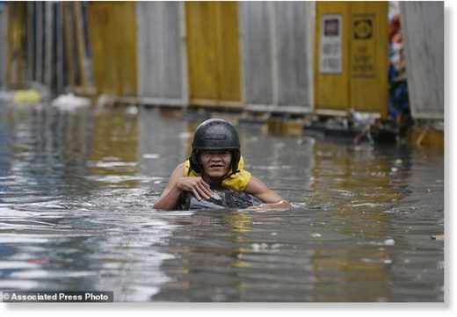
A resident uses a makeshift floater as he crosses a flooded street in Manila, Philippines on Tuesday, Sept. 12, 2017.

Water along a stretch of España Boulevard was knee-high on Tuesday. Several cars ended up trapped or were forced into opposite lanes along several submerged intersections.
Though there was no flooding in the Quiapo area, commuters lined the middle of the streets waiting for PUVs.
Among these stranded commuters was a traveler who feared missing a Saudi Arabia flight the next day because the flooding had prevented her from acquiring her additional requirements.
Meanwhile, the flooding along Taft Avenue was a windfall for enterprising individuals who made extra cash by helping pedestrians cross flooded streets.
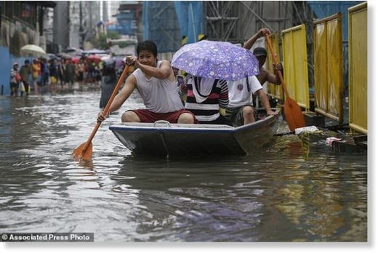
Filipinos ride a boat as they cross a flooded street in Manila, Philippines, Tuesday, Sept. 12, 2017.

Most of Taft Avenue was gutter-deep in water, and so were lanes along Padre Burgos Avenue in front of the Manila City Hall.
Boats were used as public transportation along the stretch of Ricardo Papa Street in Sta. Cruz all the way to Caloocan City. Commuters hitched rides from buses and delivery trucks to get across.
Reynaldo Cortuna of the Responder Centralized Command and Control Center said all roads in Manila were passable by noon due to government anti-flooding projects.
Other NCR areas that experienced flooding were Parañaque, Marikina, Pasig, and QC.

https://www.sott.net/article/361856-Tropical-Storm-Maring-floods-metro-Manila-Philippines

80 people killed by lightning strikes from April 1 to August 28 in Myanmar (Burma)
Myat Moe Aung
Myanmar Times
Wed, 13 Sep 2017 12:29 UTC
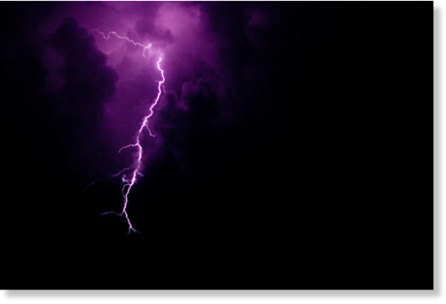

From April 2016 to the end of last year, 59 people died from lightning strikes, but this year the figure rose to 80 between April and August 28, with another 25 people injured, according to the Department of Relief and Resettlement.
Previously, lightning strikes were not taken as seriously as today. Lightning strikes are often associated with cumulonimbus clouds, which are dense tower-shaped clouds at the origin of thunderstorms and atmospheric instability. These clouds are capable of producing lightning and other dangerous weather, such as tornadoes, according to the Department of Meteorology and Hydrology.
Cumulonimbus clouds are the main source of lightning strikes. In the past few years, lightning strikes used to happen at the end and beginning of the monsoons. This year, cumulonimbus clouds remained for the whole rainy season due to irregular raining, said U Kyaw Moe Oo, associate director general of the Department of Meteorology and Hydrology.
This year, all states and regions suffered casualties, beside from Chin State. Deaths from lightning strikes were the highest in Ayeyarwady Region with 18; Bago Region had 12 deaths; Tanintharyi Region, Magwe Region, Shan state and Mandalay Region all had seven; and Yangon Region had six deaths.
"Last year, we indemnified for deaths by lightning. This year we compensate for both deaths and injuries: K300,000 for death and K50000 for injury," said Daw Phyu Lai Lai Tun, deputy director of Department of Relief and Resettlement.
Ayeyarwady Region and Bago Region were most affected as they are plains regions, said Dr. Kyaw Moe Oo.

https://www.sott.net/article/361858-80-people-killed-by-lightning-strikes-from-April-1-to-August-28-in-Myanmar-Burma

At least 9 killed, 5 injured by lightning strikes across Odisha, India
Odisha Sun Times
Tue, 12 Sep 2017 12:38 UTC

At least nine people were killed and five others injured in separate lightning incidents in Odisha on Tuesday.
While Laxmi Majhi (35) and her sister-in-law Bhagabati Majhi (20) at Baruamunda village under Komna police limits in Nuapada district were killed due to lightning strikes one died another injured in Banta block of Bhadark.
Among other deaths, two persons- one each from Bada Barahampur in Kholar panchayat under Delang block and Pubasasan village under Pipili in Puri district were killed due to lightning.
Similarly, a man was killed his wife sustained injuries at Sosa Sankatapali villager under Anandapur of Keonjhar district.
A person and two cows were killed due to lightning strikes at Bhaguathenga under Kujanda in Paradip of Jagatsinghpur.
A man was injured in Sundergarh district while two persons were critically injured after being struck by lightning at Batira village in Kendrapara district.
Reports said lightning struck while most of the deceased were working in paddy fields and some others were taking shelter under a tree during the rain.

https://www.sott.net/article/361859-At-least-9-killed-5-injured-by-lightning-strikes-across-Odisha-India

San Francisco sees 1,200 lightning strikes in rare September thunderstorms
Alix Martichoux
SFGate
Tue, 12 Sep 2017 16:45 UTC
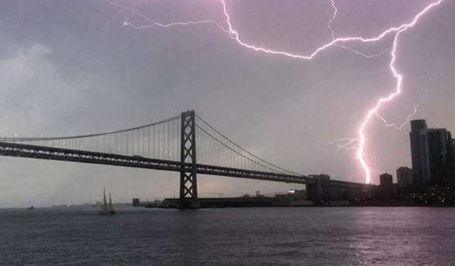
© Instagram / Lacey_bannister

Updated on September 12 at 7:20 a.m.: The National Weather Service reported Tuesday morning that 1,200 cloud-to-ground strikes and 5,800 in-cloud strikes hit the Bay Area Monday night.
"You can see both," says Scott Rowe, a meteorologist with the National Weather Service office in Monterey. "Both are just as dangerous."
It started with strong wind gusts between 35 and 50 mph that roared through Monterey County and parts of the South Bay in the early morning hours. Later in the day, temperatures climbed to the 90s in San Jose and the high 80s in San Francisco.
Then came the rain, thunder, and lightning. The National Weather Service tweeted out that the Bay Area saw more than 800 lightning strikes and cloud flashes between noon and 5 p.m.
By the time thunderstorms bubbled up over parts of the Bay Area Monday afternoon, some people had had enough.
"Feels more like Mexico than Berkeley!" said Twitter user @leahmichon.
The Palo Alto Fire Department tweeted out an alarming message with multiple exclamation points: "Lightning & thunder passing over @cityofpaloalto right now. When thunder roars, head indoors!!!"
Some people didn't heed the fire department's warning, instead heading outside to take pictures and video of the lightning strikes.
The National Weather Service predicts a 20 to 30 percent chance of thunderstorms overnight into Tuesday morning for San Francisco. Tuesday will be partly cloudy with a high in the mid-70s, before a 20 percent chance of rain and thunderstorms returns at night.
Extended view of the storm:
Comment:
- Electric universe: Lightning strength and frequency increasing
- Sott Exclusive: Shocking weather! Lightning fatalities across the planet on the increase
- Solar Wind Provokes Lightning on Earth

https://www.sott.net/article/361899-San-Francisco-sees-1200-lightning-strikes-in-rare-September-thunderstorms

Solar Activities
THE CME HAS ARRIVED: A CME has just hit Earth's magnetic field. This is the CME from Wednesday's decade-class solar flare. It arrived earlier than expected, confirming that the storm cloud is both fast and potent. The CME appears to contain strong south-pointing magnetic fields that do a good job of igniting geomagnetic storms. High-latitude sky watchers should be alert for auroras in bright moonlight. Free: Aurora Alerts
THE FLARES CONTINUE: Sunspot AR2673 has remained active on Sept. 7th, producing three M-class flares (M2.4, M1.4, M7.3) and another X-flare (X1.3). Unlike yesterday's monster X9-flare, however, none of today's explosions have hurled a significant CME toward Earth. Ham radio operators may be noticing the effects of these most recent flares in the form of minor shortwave blackouts and strange propagation effects. Free: Solar Flare Alerts
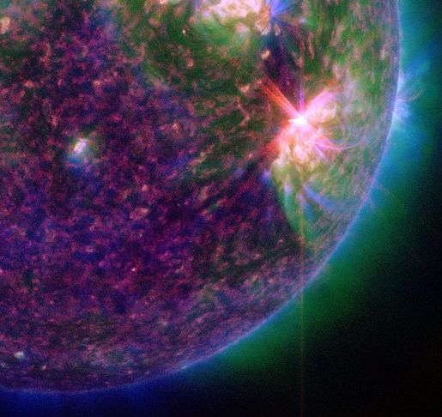
Above: The extreme ultraviolet flash from an M7-class flare on Sept. 7th. Credit: NASA/SDO
Realtime Space Weather Photo Gallery
EARTH VS. SOLAR FLARE: Amateur astronomer Philippe Tosi photographed the sun on Sept. 6th, and his timing was perfect. He caught sunspot AR2673 in mid-explosion, producing the most powerful solar flare in more than a decade.
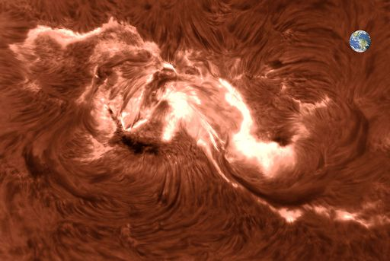
His image of the X9-category blast, with Earth inserted for comparison, highlights the advantages of being 93 million miles away from the sun. The explosion was big enough to swallow our entire planet with room to spare.

Many readers are asking about the historic context of this event. How epic is it? Answer: This is a decade-class flare. A list of the most powerful solar flares recorded since 1976 ranks the Sept 6th flare at #14, tied with a similar explosion in 1990. However, compared to the iconic Carrington Event of 1859, or even the more recent Halloween storms of 2003, this event is relatively mild. Modern power grids, telecommunications, and other sun sensitive technologies should weather the storm with ease.
GEOMAGNETIC STORM PREDICTED: NOAA forecasters say there is a 60% chance of moderately strong (G2-class) geomagnetic storms on Sept. 13th. That's when a CME hurled into space by yesterday's powerful X8-class solar flare could deliver a glancing blow to Earth's magnetic field. In the United States, auroras could appear as low as New York to Wisconsin to Washington state. Free: Aurora Alerts
SOLAR RADIATION STORM AND GROUND LEVEL EVENT: On Sept. 10th, departing sunspot AR2673 erupted, producing a powerful X8-class solar flare. The explosion propelled a CME into space and accelerated a swarm of energetic protons toward Earth. Both are visible in this coronagraph movie from the Solar and Heliospheric Observatory (SOHO):
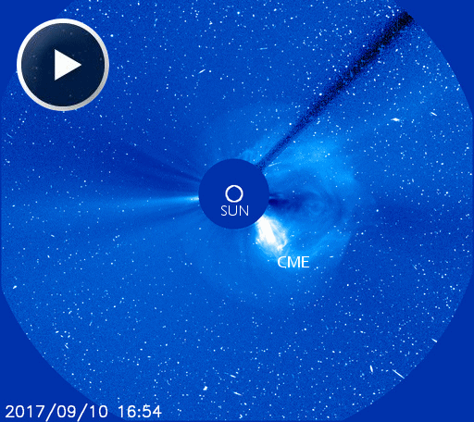
The many specks in this movie are not stars--they are solar protons striking SOHO's digital camera. On Sept. 11th these protons are still streaming past our planet, causing a moderately strong (S2-class) solar radiation storm.
When it exploded on Sept. 10th, sunspot AR2673 was on the sun's western limb. It turns out, this is a special location: The sun's western limb is magnetically well-connected to Earth. Look at this diagram. Magnetic fields spiraling back from the blast site led directly to our planet, funneling these energetic protons Earthward for the ongoing radiation storm.
Normally, solar radiation storms are held at bay by our planet's magnetic field and upper atmosphere. On Sept.10th, however, there was a "ground level event" (GLE). Neutron monitors in the Arctic and Antarctic detected a surge of particles reaching all the way down to Earth's surface. These data, for instance, from the Bartol Research Institute's South Pole Neutron Monitor clearly show the GLE:
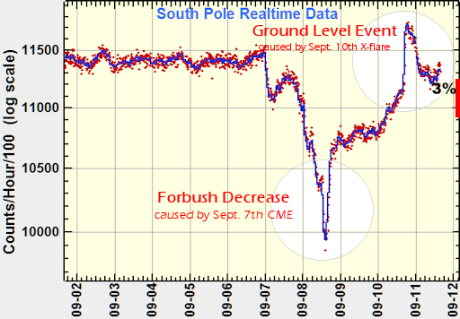:
"Radiation levels jumped about 6%," reports Clive Dyer, a visiting Professor at the University of Surrey Space Centre. "In historical terms, it was a relatively small one -- only about one thousandth as strong as the event of 23 Feb 1956, which is the largest measured."
Nevertheless, it could have made itself felt at aviation altitudes. Dyer says that "passengers flying on high-latitude routes at 40,000 feet could have absorbed an extra 10 microSieverts of radiation," approximately doubling the usual dose on such a flight.

GLEs are somewhat rare. "Since measurements began around 1942 there have now been 73 events detected by ground level radiation monitors," he adds. "The Sept.10, 2017, event is of interest because it demonstrates the need for continual vigilance even during Solar Minimum."
Near Earth Asteroids

Potentially Hazardous Asteroids (PHAs) are space rocks larger than approximately 100m that can come closer to Earth than 0.05 AU. None of the known PHAs is on a collision course with our planet, although astronomers are finding new ones all the time.
On September 13, 2017 there were 1803 potentially hazardous asteroids.
Recent & Upcoming Earth-asteroid encounters:
Asteroid | Date(UT) | Miss Distance | Velocity (km/s) | Diameter (m)
2017 OP68 | 2017-Sep-10 | 20 LD | 11.7 | 262
2017 QK18 | 2017-Sep-11 | 14.8 LD | 7.8 | 45
2014 RC | 2017-Sep-11 | 15.1 LD | 8.9 | 16
2017 PR25 | 2017-Sep-23 | 17.9 LD | 13.5 | 239
1989 VB | 2017-Sep-29 | 7.9 LD | 6.3 | 408
2017 OD69 | 2017-Oct-01 | 13.2 LD | 7.6 | 213
2012 TC4 | 2017-Oct-12 | 0.1 LD | 7.6 | 16
2005 TE49 | 2017-Oct-13 | 8.5 LD | 11.2 | 16
2013 UM9 | 2017-Oct-15 | 17 LD | 7.8 | 39
2006 TU7 | 2017-Oct-18 | 18.7 LD | 13.3 | 148
171576 | 2017-Oct-22 | 5.8 LD | 21.2 | 677
2003 UV11 | 2017-Oct-31 | 15 LD | 24.5 | 447  Notes: LD means "Lunar Distance." 1 LD = 384,401 km, the distance between Earth and the Moon. 1 LD also equals 0.00256 AU. MAG is the visual magnitude of the asteroid on the date of closest approach.

http://www.spaceweather.com/
Animal Deaths

Australians advised to hunt and eat kangaroos as population outnumbers humans by two to one
Harriet Pavey
Evening Standard
Mon, 11 Sep 2017 00:00 UTC
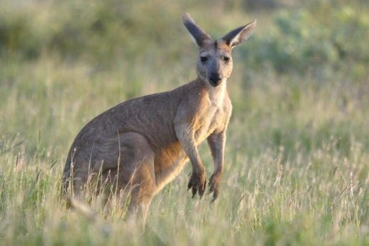
© AFP / Getty
Out of control: the kangaroo population in Australia is double that of humans

Australians have been told to hunt and eat kangaroos after the population of the marsupial reached double that of humans.
New data shows the kangaroo population in Australia is close to hitting 50 million, while the human population stands at 24 million.
Experts are now warning Australians to hunt, eat and cull the native animal or face being overrun by it.
The kangaroo population has boomed in recent years, rising to 45 million last year from 27 million in 2010, news.com.au reported. The huge rise in kangaroo numbers is thought to be due to an abundance of food after high rainfall.
David Paton, Associate Professor from the University of Adelaide, said communities needed to support kangaroo culling programmes and eat their meat to avoid wasting carcasses.
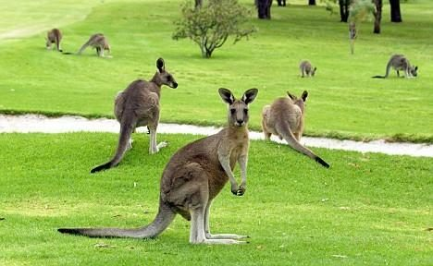
Kangaroo numbers have soared thanks to an abundance of food

"If we're going to cull these animals we do it humanely, but we also perhaps should think about what we might use the animals that are killed for," he told the ABC.
"We shouldn't just simply leave them out in paddocks to rot of leave them in the reserves to rot."
A large kangaroo population could also pose a threat to biodiversity, Professor Paton said: "It's not the kangaroos' fault they're overabundant, it's probably we've just been too reluctant to take a stick to them, remove them out of the system sooner, to actually prevent the damage being caused."
Kangaroos are seen as national pests in Australia. According to a report published by the Victorian Department of Sustainability and Environment, they damage fences, compete with domestic livestock for food and water and trample crops.
There have also been reports of kangaroos behaving violently towards humans in areas where they have been fed by members of the public

https://www.sott.net/article/361766-Australians-advised-to-hunt-and-eat-kangaroos-as-population-outnumbers-humans-by-two-to-one
MASS ANIMAL DEATH LIST
344 Known MASS Death Events in 70 Countries (or Territory)
12th September 2017 - 800+ dead sea birds found on islands in the Bering Sea, America. Link
12th September 2017 - 42 Hippos dead due to outbreak of disease in Ruaha National Park, Tanzania. Link
11th September 2017 - 100+ dead sea birds found on a beach in Pembrokeshire, Wales. Link

http://www.end-times-prophecy.org/animal-deaths-birds-fish-end-times.html
The Earth

Wildfires in Oregon consume over 10,000 acres of forest, haunting images of smoke and ash visible from space
RT
Thu, 07 Sep 2017 15:25 UTC
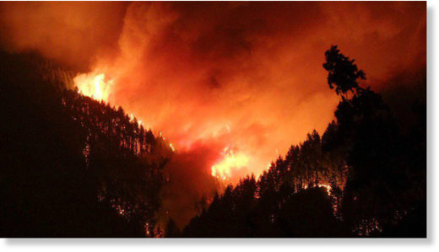
© Travis Madison / Facebook

Wildfires are engulfing the Columbia River Gorge in Oregon, with more than 10,000 acres of forest destroyed. The inferno is sending smoke and ash into the sky which is visible from space. Hundreds of people have been forced to evacuate the area.
"The biggest danger isn't necessarily the fire pushing through - it's the ash fall," said Lt. Damon Simmons, spokesman for the Oregon State Fire Marshal's Office, as cited by The Hood River News.
Ash from the fire has reached as far as the Hood River 47 miles (76km) away with massive smoke trails from the inferno visible from space.
The Eagle Creek fire was man-made, has evaded containment and now covers an area of more than 10,000 acres since it broke out Saturday. The fire even jumped the Columbia River to Washington in the early hours of Tuesday morning, reports King 5 News.
Police interviewed a 15-year-old male from Vancouver, Washington they believe started the fire by setting off fireworks on the Eagle Creek Trail.
Travis Madison was in the area at the weekend and managed to capture some incredible photographs.
"I was up there during the day the fire broke out taking pictures and hiking when all of a sudden I noticed smoke coming from one of the hills. That's when I immediately started taking pics of the fire," Madison told RT.com.
"I spent the night driving around catching pics of the fire and got as close as I could get. Then, officers were doing mandatory evacuations for residents and hikers because the winds pushed it out of control."
A total of four fire crews, 29 engines and five helicopters were brought in to tackle the massive fire with additional firefighting planes also called upon. However, the thick clouds of smoke have hampered firefighting efforts, reducing visibility dramatically and grounding air operations.
The blaze is located eight miles from the month-old Indian Creek fire which broke out on July 4. More than 500 personnel are involved in containment, rescue and firefighting operations between the Indian and Eagle Creek fires.
Hundreds of local residents were forced to evacuate since Sunday with the most recent evacuation order issued early Tuesday afternoon.
The Oregon Department of Transportation was forced to close Interstate 84 at 6pm Monday, just as Labor Day weekend traffic was returning.
The pace of the fire has slowed dramatically according to police, but major firefighting operations will continue to bring the firestorm under control.

https://www.sott.net/article/361365-Wildfires-in-Oregon-consume-over-10000-acres-of-forest-haunting-images-of-smoke-and-ash-visible-from-space

The 275 trillion pounds of water from Hurricane Harvey deformed the earth's crust in Houston
Alexis C. Madrigal
The Atlantic
Tue, 05 Sep 2017 00:00 UTC
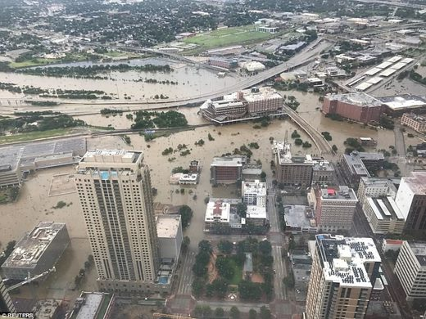
An aerial photograph reveals the huge swathes of flooded land in Houston, Texas on Sunday. Hurricane Harvey blustered through the town on Friday and Saturday, bringing with it unprecedented downpour and triggering life-threatening floods.

The weight of water can deform the Earth's crust, if there's enough of it. And we can measure that change with the ultraprecise global-positioning satellites humans have launched into orbit.
On Monday, Chris Milliner of the Jet Propulsion Laboratory tweeted a simple map visualizing data from the Nevada Geodetic Laboratory. It showed that the GPS data from special stations around Houston detected that the whole area had been pushed down roughly two centimeters by the weight of the water that fell during Hurricane Harvey.
Why this would happen is simpler than you might think. A gallon of water weighs about 8.34 pounds. And by one estimate, Harvey dropped 33 trillion gallons of water across the area it hit. So that's roughly 275 trillion pounds.
And it turns out that scientists have measured the effects of loading a bunch of water onto land many times. For example, a 2012 study of the Himalayas detected a seasonal flux in the height of the mountains as water fell, and then ran off those mountains into Asia's rivers.
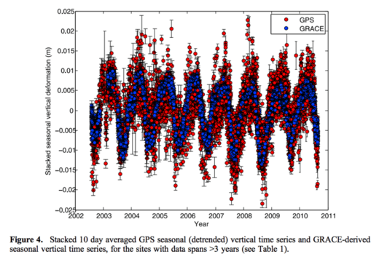

A 2017 study in Science found that the Sierra Nevada exhibits "vertical surface displacement [with] peak-to-peak amplitudes" of 0.5 to one centimeter. More water is more mass. Less water is less mass. And the crust underneath that water responds to the changes.
One could see Harvey's deposition of water as a fast-action version of what happens in the Earth's mountain ranges each year.
There are some caveats, Milliner later explained. Some of the change could come from the soil underneath the GPS stations becoming compacted by the water's weight. But because some stations located on bedrock also experienced the depression, he believed that the key mechanism was crust deformation. It's also possible, he elaborated, that some areas outside Houston were pushed up by the way the water squished the Houston crust.
Perhaps a hurricane seems a match for the crust of the Earth, in mental scale. But humans can also have this sort of effect (even without calculating how much of Harvey's water was due to climate change). Huge dams can impound water on a scale of Hurricane Harvey's rains. The Hoover Dam and Three Gorges Dam both created reservoirs with a capacity of roughly 10 trillion gallons of water.
The effect of the filling of the Three Gorges Dam has experienced substantial attention from Chinese researchers, in part because there was a marked increase in small earthquakes in the region as the reservoir was filled. That's not a concern in Houston, which is not a seismically active region.
It also remains to be seen how quickly the Earth rebounds in Houston, given that the water is rushing back to the sea, rather than sitting on mountaintops as glaciers or in reservoirs as hydrologic storage. And one assumes there's an interesting paper in that for a geodetic researcher.
And there are (at least) two more ways humans are changing the crust of the Earth. Because the climate is warming, there's less ice-and therefore less mass-attached to the world's mountaintops. "The Earth, behaving like an elastic body, uplifts in a response to the load loss," the Himalayan researchers write.
Comment: Well no, actually the climate is experiencing a cooling trend. The Arctic sea ice melt season is behaving strangely, showing signs of an early end to the melt season. Winter has arrived about 10 days early in the Arctic, and Greenland's surface has gained 500 billion tons of ice - about 33% above normal.
Meanwhile, in Houston, the ground had already been sinking-scientists call it subsidence-because humans have pumped the groundwater out of the aquifers under the city.
With each passing year, the combined and uncoordinated efforts of humanity force the mountains a little higher and the flats a bit lower.
https://www.sott.net/article/361384-The-275-trillion-pounds-of-water-from-Hurricane-Harvey-deformed-the-earths-crust-in-Houston

Deep sinkhole several meters wide opens in Brussels, Belgium
9News
Fri, 08 Sep 2017 16:38 UTC
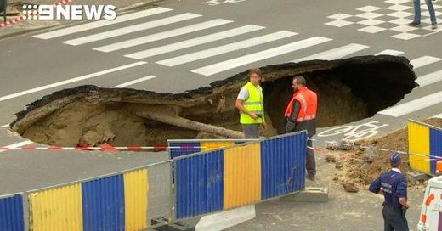
© 9News

A sinkhole several metres wide appeared on a busy street in Brussels on Thursday, shutting the road to traffic and worrying local residents.
The hole, caused by a leak in underground water pipes, did not result in any injuries according to local media, but restaurant owner Massut Ozkan said he had to hurry to halt buses and cars heading for the street when the hole appeared.
"We stopped the traffic. I went up to stop all the cars. There were also buses, fortunately they didn't go down the road. We stopped everybody, on both sides of the street. Honestly, we avoided a serious danger. If a big bus or a van had gone by, things would not be the same," he said.
The road has been closed for safety reasons and 200 people evacuated, according to local media.
Trains have also been affected with officials saying some traffic between Bruxelles-Nord and Bruxelles-Schuman stations will be interrupted for days.
https://www.sott.net/article/361459-Deep-sinkhole-several-meters-wide-opens-in-Brussels-Belgium

Eerie green glow appears over Tonbridge in Kent, UK
Rob Waugh
Metro, UK
Wed, 06 Sep 2017 14:43 UTC
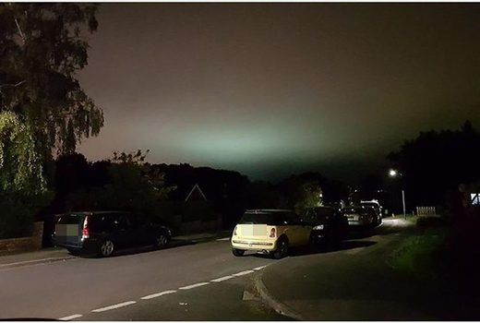
© Wessex News

Hand on heart, we'll admit that Tonbridge in Kent is a pretty odd place for an alien invasion to start - but residents spotted something very odd last night.
An eerie green glow in the sky - far too far south to be the northern lights.
So it's obviously Martians, right?
Tonbridge's green tinge in the night sky was visible for miles around the town, with motorists reporting it from far afield, and it was at its strongest from around 8pm to 10pm.
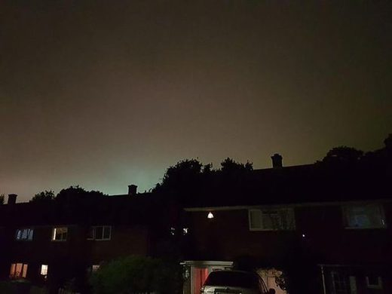
© Clare Marco

Some locals claimed it could be 'aluminium in the atmosphere'.
Local resident Stuart Purchard said the phenomenon 'happens every year' and claimed it emanated from Tonbridge School, where 'the hockey pitch floodlights make an eerie green light from the pitch after it's been damp or raining'.
But Clare Macro, who took several pictures of the glow, said, 'I've checked Tonbridge School and found it was not the source. It's a real mystery."
https://www.sott.net/article/361461-Eerie-green-glow-appears-over-Tonbridge-in-Kent-UK

Floods kill at least six in Livorno, Italy; 15 inches of rain in 4 hours
The Straits Times
Sun, 10 Sep 2017 14:14 UTC
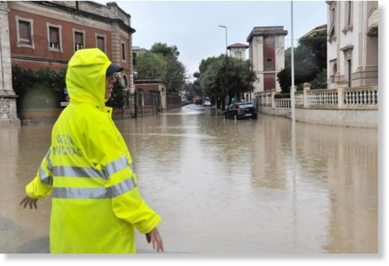
© EPA
A police officer stands in a flooded crossing in Livorno, Italy, on Sept 10, 2017.

At least six people have died in violent rainstorms sweeping across Italy on Sunday (Sept 10), with the Tuscan city of Livorno taking the brunt of the flooding, fire services said.
Four people from the same family were found dead in a flooded house in the city, where 40cm of rainfall in four hours transformed streets into rivers and washed away cars.
The Corriere della Sera daily said the dead were a little girl, her parents and a grandparent.
A fifth body was found in an area devastated by landslides. Three other people were missing, the fire brigade said.
"The situation is very difficult, it's critical. We fear a disaster," Livorno mayor Filippo Nogarin said.
Italy's civil protection service issued a code orange alert for Florence as the storms, which began in northern Italy overnight, swept down the country towards the south.

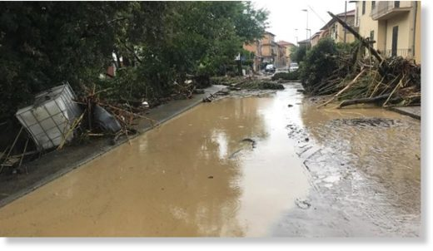
© Alessio Novi
Trees lie on a flooded street in Leghorn, Italy, Sunday, Sept. 10, 2017.

Underpasses were being closed as a precaution in the capital Rome.
Coldiretti, Italy's main agricultural organisation, said the bad weather was aggravated by coming hard on the heels of a drought which had left the land drier than usual and unable to soak up the rains.
Rainfall in Tuscany in particular had been down 57 per cent this summer, it said.
"The tropicalisation of the climate is causing an increase in extreme weather events, with heat waves, heavy cloud bursts and violent hailstorms which are damaging the national agricultural production," Coldiretti said.
It put the cost of the damage at over 14 billion euros (S$22.54 billion) in the last 10 years.
https://www.sott.net/article/361600-Floods-kill-at-least-six-in-Livorno-Italy-15-inches-of-rain-in-4-hours

September so far has been an almost apocalyptic month of environmental events
Michael Snyder
The Economic Collapse
Sun, 10 Sep 2017 00:00 UTC


Two major hurricanes, unprecedented earthquake swarms and wildfires roaring out of control all over the northwest United States - what else will go wrong next? When I originally pointed to the month of September as a critical time, I had no idea that we would see so many catastrophic natural disasters during this time frame as well. Hurricane Harvey just broke the all-time record for rainfall in the continental United States, Hurricane Irma is so immensely powerful that it has been called "a lawnmower from the sky", vast stretches of our country out west are literally being consumed by fire, and the magnitude-8.2 earthquake that just hit Mexico was completely unexpected. As I have stated so many times before, our planet is becoming increasingly unstable, but most people simply do not understand what is happening.
My good friend Zach Drew is getting married next month, and I would encourage everyone to go wish him well on Facebook. On Friday, he posted the best summary of the major disasters that we have been experiencing so far this month that I have seen anywhere...
- California is on fire.
- Oregon is on fire.
- Washington is on fire.
- British Columbia is on fire.
- Alberta is on fire
- Montana is on fire.
- Nova Scotia is on fire.
- Greece is on fire.
- Brazil is on fire.
- Portugal is on fire.
- Algeria is on fire.
- Tunisia is on fire.
- Greenland is on fire.
- The Sakha Republic of Russia is on fire.
- Siberia is on fire.
- Texas is under water
- India, Nepal, Pakistan, and Bangladesh, experience record monsoons and massive death toll.
- Sierra Leone and Niger experience massive floods, mudslides, and deaths in the thousands.
- Italy, France, Spain, Switzerland, Hungary, Poland, Romania, Bosnia, Croatia, and Serbia are crushed in the death grip of a triple digit heat wave, dubbed Lucifer.
- Southern California continues to swelter under triple digit heat that shows no sign of letting up.
- In usually chilly August, the city of San Francisco shatters all-time record at 106 degrees, while it reaches 115 degrees south of the city. Northern California continues to bake in the triple digits.
- Yellowstone volcano is hit with earthquake swarm of over 2,300 tremors since June, recording a 4.4 quake on June 15, 20017 and 3.3 shaker on August 21, 2017.
- 5.3 earthquake rumbles through Idaho
- Japan earthquake 6.1 possible tsunami..
- Mexico earthquake 8.2 imminent tsunami. Beach lines are receded atleast 50+ meters

Comment:
- Huge spring snow dump of 31 inches in 3 days at Mt Ruapehu, New Zealand
- Australia shivers through coldest start to September EVER: Freezing weather and record Spring snowfall turns coastal towns white
- Snow already! Mount Washington in New Hampshire gets its first taste of winter
- Hot summer ends in the Sakha Republic, Russia with cold blast and abnormal August snow
Hurricanes Harvey, Irma (biggest ever recorded), Jose and Katia are barreling around the Atlantic with 8 more potentials forming
And last but not least an X10 C.M.E solar flare two nights ago. The highest recorded solar flare ever!
*****
For much more from Zach, you can follow his work regularly at TruNews.com.
Some are describing what is happening to us as a "perfect storm", and they are wondering if even more major disasters are coming in the very near future.
Let us hope not, because there is a tremendous amount of concern that we may not be able to pay for the disasters that have happened already. The following comes from Politico...
Harvey and Irma could be a breaking point. At $556 billion, the Houston metropolitan area's economy is bigger than Sweden's. New Jersey could easily fit inside the region's sprawling footprint, where Harvey dumped 34 trillion gallons of water, as much as the three costliest floods in Texas history combined. The Harvey response alone eventually could double the $136 billion in government aid spent after Hurricane Katrina flooded New Orleans.
And as of Friday, an estimated $1.73 trillion worth of real estate was in the path of Irma's hurricane-force winds, according to the University of Wisconsin's Cooperative Institute for Meteorological Satellite Studies.
We won't know the true extent of the damage that has been caused down in Florida for many days, but we do know that much of the state is already without power...
More than 3.3 million homes and businesses and counting have lost power in Florida as Hurricane Irma moves up the peninsula. The widespread outages stretch from the Florida Keys all the way into central Florida. Florida Power & Light, the state's largest electric utility, said there were nearly 1 million customers without power in Miami-Dade County alone. The power outages are expected to increase as the storm edges further north. There are roughly 7 million residential customers in the state.
In the end, the federal government will likely step in and spend a lot of money that it does not have to rebuild and restore the communities that Hurricane Harvey and Hurricane Irma have destroyed.
But we are already 20 trillion dollars in debt, and it is being projected that we will continue to add another trillion dollars to that total every year for the foreseeable future.
At some point all of this debt will simply become completely unsustainable.
Of course the major disasters will just inevitably keep on coming. As Politico has pointed out, major natural disasters seem to just keep on getting bigger, and they seem to be hitting us more frequently than in the past...
The disasters are arriving with greater frequency. Counting Harvey, the U.S. this year has experienced 10 weather-related events each costing $1 billion or more. The country averaged fewer than six big-dollar storms, flood, fires and freezes a year between 1980 and 2016, according to the National Oceanic and Atmospheric Administration. Between 2012 and 2016, however, weather catastrophes occurred almost twice as often.
I know that I have been writing about these hurricanes a lot in recent weeks, and I promise to get back to focusing on the economy in the days to come.
But it is absolutely imperative that we all begin to understand that something has fundamentally changed. Our world has become much less stable, and "apocalyptic events" are starting to hit us one after another.
https://www.sott.net/article/361699-September-so-far-has-been-an-almost-apocalyptic-month-of-environmental-events
Strange & Pestilence

Flesh-eating fungus threatens to wipe out fire salamanders across Germany
Deutsche Welle
Sat, 09 Sep 2017 10:55 UTC

Fire salamander

A deadly flesh-eating fungus responsible for decimating fire salamander populations in Europe is spreading in Germany, according to researchers.
The Batrachochytrium salamandrivorans fungus first arrived in Europe from Southeast Asia in 2010, wiping out fire salamander populations in Belgium and resulting in severe declines in the Netherlands.
It was first detected in western Germany's Eifel region in 2015, but has recently been found in Essen, nearly 100 kilometers away (60 miles).
"This is a rapid spread and it can occur throughout the country," Sebastian Steinfartz, a researcher at TU Braunschweig's Zoological Institute, told news agency DPA.
The black-and-yellow spotted fire salamander is one of the best-known species in Europe.
Threat of extinction
The fungus causes skin ulcers and tumors that make the fire salamanders susceptible to other diseases. It is highly virulent and spreads rapidly thanks to thick spore walls that increase its longevity.
A study in the journal Nature published in April warned that infected fire salamander populations dropped by 90 percent before eventually being wiped out.
The pathological fungus can spread through the soil, water and air. Birds and frogs also carry the fungus. Other amphibians like newts and toads are also susceptible to the fungus and carry it.
It is believed the fungus spread to Europe through the forestry, agricultural and wildlife trade.
The Nature study found that sexually mature fire salamanders were particularly susceptible to contracting the fungus because they come into contact with other fire salamanders. This, in turn, furthers pressure on the species.
Scientists are worried that fire salamanders could be completely wiped out as they have no immune response and there is no easy way to stop the fungus from spreading.
Matthew C. Fisher, an expert in fungal epidemiology at Imperial College London, in a comment published with the Nature study suggested the only way to save salamanders in Europe may be to keep a population in captivity until the fungus is controlled or a cure is found.
https://www.sott.net/article/361590-Flesh-eating-fungus-threatens-to-wipe-out-fire-salamanders-across-Germany

Behind the Headlines: Wild Climes, Geopolitical Earthquakes and Putin's Force of Nature‌
Sott.net
Sun, 10 Sep 2017 16:00 UTC
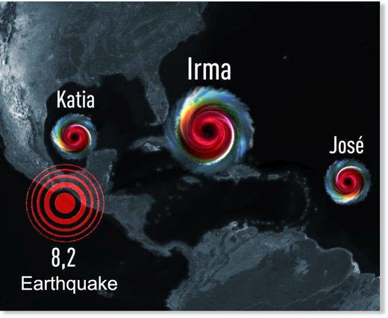
Irma et Jose font tomber le record des ouragans simultanés les plus puissants.

This week on Behind the Headlines we're taking in some of the wild weather currently rocking the planet. Not two weeks after Harvey pummeled the Texas coast, the Caribbean is recovering from an extremely powerful hurricane, and Florida's next in its sights.
Also this week, Mexico's strongest-ever earthquake coincided with the strongest solar flare in over a decade, as well as the impact of yet another hurricane. In the north of the continent, another record-breaking wildfire season - coming after record-breaking snowfalls last winter - just won't end.‌
In the meantime, this week's geopolitical earthquakes in and around northeast Asia saw BRICS nations strengthen economic ties and their positions on North Korea's nukes. Leading the way is another 'force of nature', Vladimir Putin, whose patience is paying off in Syria, where the last major ISIS stronghold of Deir ez Zor collapsed last week.‌
Join us this Sunday 3 September 2017 from 12-2pm EST (4-6pm UTC / 6-8pm CET) for the end of the world as we know it!
https://www.sott.net/article/361621-Behind-the-Headlines-Wild-Climes-Geopolitical-Earthquakes-and-Putins-Force-of-Nature

Huge swarm of locusts devastate swathes of farmland in southern Russia
Stewart Paterson
Daily Mail
Sat, 09 Sep 2017 13:39 UTC

The video, which was shot last month, shows a group of fishermen as they battle past the swarm of locusts

Horrifying footage shows an enormous swarm of locusts devouring everything in their path in a Russian town.
Innumerable insects filled the skies of Ninovka, in the south of the country, to the horror of locals.
The video, which was shot last month, shows a group of fishermen as they battle past the swarm of locusts.
It comes as huge migrations of the flying insects have devastate farms in southern Russian and surrounding regions.


In come cases, whole pastures have been destroyed leaving farmers without food to feed their cattle

In some cases, whole pastures have been destroyed leaving farmers without food to feed their cattle.
They say the arrival of the yearly swarms are signalled by long periods of hot, dry weather.
But resourceful fishermen have made the most of the swarms — catching the insects in nets to use as bait.
Officials said trying to scare the insects off with noise - which had worked previously - failed this year, according to Russian media.

But resourceful fishermen have made the most of the swarms — catching the insects in nets to use as bait.
https://www.sott.net/article/361662-Huge-swarm-of-locusts-devastate-swathes-of-farmland-in-southern-Russia

Squirrels attack residents of Lake Vista, New Orleans in at least 4 incidents
Paul Murphy
wwltv.com
Wed, 13 Sep 2017 12:54 UTC


In the Lake Vista neighborhood of New Orleans, neighbors live along lush, tree-lined lanes in harmony with nature.
But, this week nature attacked.
"All of a sudden I felt something on my back and it was a squirrel," Gary Prechter said. "I grabbed it and I flung it down on the lane and it turned around and came back at me. It attached itself to my ankle and started biting me and scratching me and I tried to get it off as best I could."
Prechter is one of at least four people who've had violent encounters with Lake Vista neighborhood squirrels in recent days.
The pastor at St. Pius Catholic Church confirms two women were attacked in his parking lot after Sunday mass.

A squirrel in Lake Vista, possibly one of four who have allegedly attacked some residents.

Another man was reportedly assaulted by a squirrel that managed to get into his house.
"I'm telling everybody in the neighborhood beware of the squirrels," Prechter said. "Don't feed them any longer. They're not you're friend."
The squirrel attacks have Lake Vista neighbors keeping their situational awareness.
"I haven't seen any aggressive squirrels, usually I'm walking with the dog and they're running away from me," neighbor Brian Ferrara said. "They are usually afraid of the people. They are usually running away."
Prechter is now receiving a painful series of shots for rabies as a precaution.
"I paid my daughter ten bucks to take the garbage out to the lane because I'm not going outside," Prechter said. "I'm wearing boots and long pants to my series of rabies shots set in and then I'm ready to take on the world."
The staff at St. Pius reported the incident involving the two parishioners to New Orleans Animal Control which is now taking steps to trap the offenders.
The city is looking for two squirrels of interest, living not far from the church
Once they are caught, the state veterinarian has agreed to test them for rabies.
A city spokeswoman passed on some advice on how to live with nature.
She said keep your distance and don't feed wild animals, it desensitizes there natural instinct to steer clear of humans.
https://www.sott.net/article/361860-Squirrels-attack-residents-of-Lake-Vista-New-Orleans-in-at-least-4-incidents

